**NAAN MUDHALVAN PROJECT REPORT**

**CRM APPLICATION FOR JEWEL MANAGEMENT (DEVELOPER)**

**COLLEGE NAME:** SRI KRISHNA ADITHYA COLLEGE OF ARTS AND SCIENCE

**COLLEGE CODE:** bruag

**TEAM ID:** NM2025TMID22798

**TEAM MEMBERS:**

Team Leader Name: MOHAMMED AFRAAN M

Email:[23bsds133mohammedafraanm@skacas.ac.in](mailto:23bsds133mohammedafraanm@skacas.ac.in)

Team Member 1: MOHAMMED SUHAIL H

Email: [23bsds136mohammedsuhailh@skacas.ac.in](mailto:23bsds136mohammedsuhailh@skacas.ac.in)

Team Member 2: RITHIK K

Email: [23bsds146rithikk@skacas.ac.in](mailto:23bsds146rithikk@skacas.ac.in)

Team Member 3: SANJAY ARAVINTH S

Email: [23bsds151sanjayaravinths@skacas.ac.in](mailto:23bsds151sanjayaravinths@skacas.ac.in)

**1.INTRODUCTION**

**1.1 PROJECT OVERVIEW**

The Jewel Inventory System is a comprehensive software Solution designed to streamline and manage the inventory and sales processes of a jewellery store or a jewellery manufacturer. The system aims to provide an efficient and user-friendly solution to track and control the inventory of various jewellery items, maintain accurate records, and facilitate seamless sales transactions.

**1.2 PURPOSE**

The purpose of the Jewel Inventory System is to provide an integrated, user-friendly platform that enables jewelry stores and manufacturers to efficiently manage inventory, track item movement, ensure accurate stock records, and streamline sales operations. It aims to reduce manual errors, enhance operational visibility, and support better decision-making through real-time data and reporting.

**DEVELOPMENT PHASE**

**Creating a developer account**

By using this url: <https://www.salesforce.com/form/developer-signup/?d=pb>

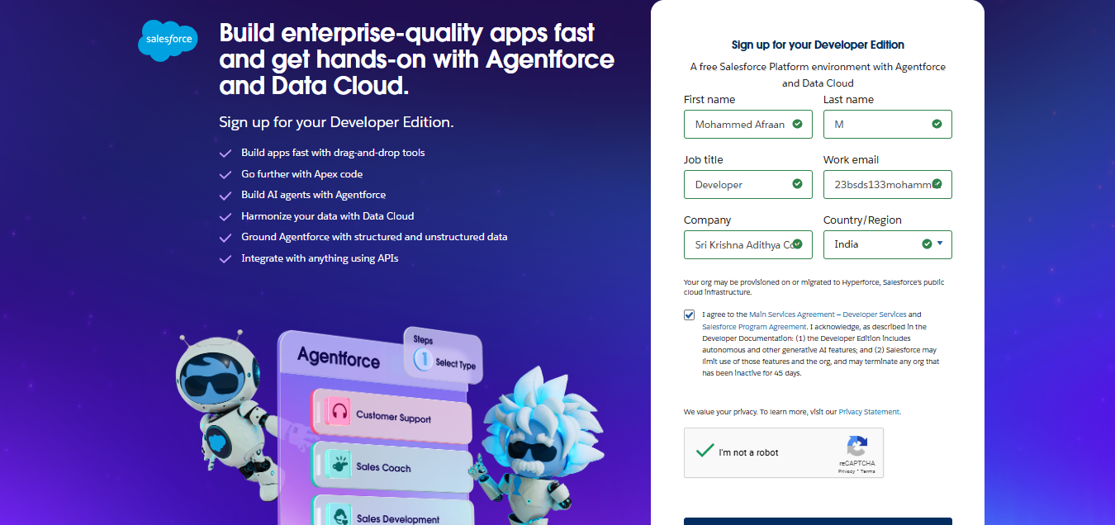

**Created Objects**

Jewel Customer

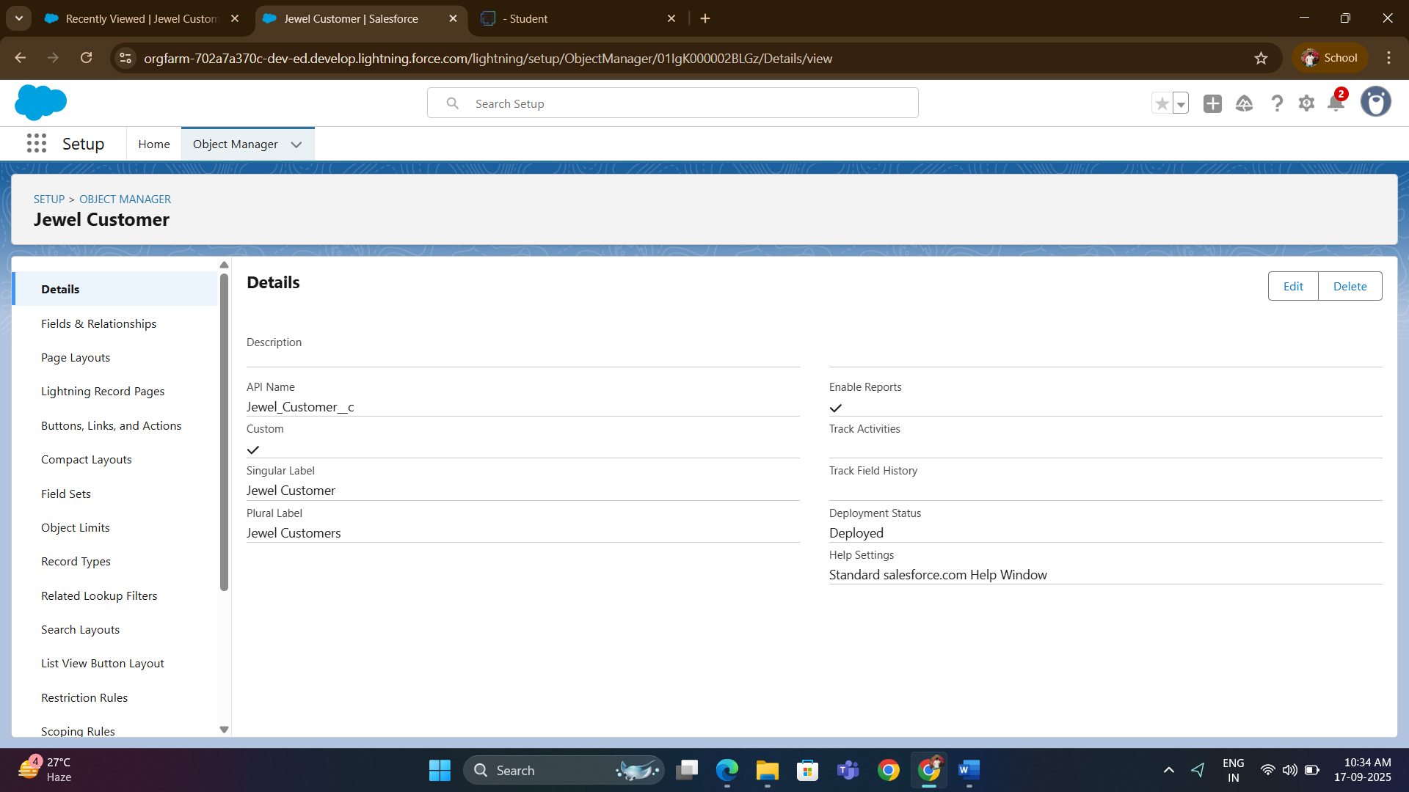

Customer Order

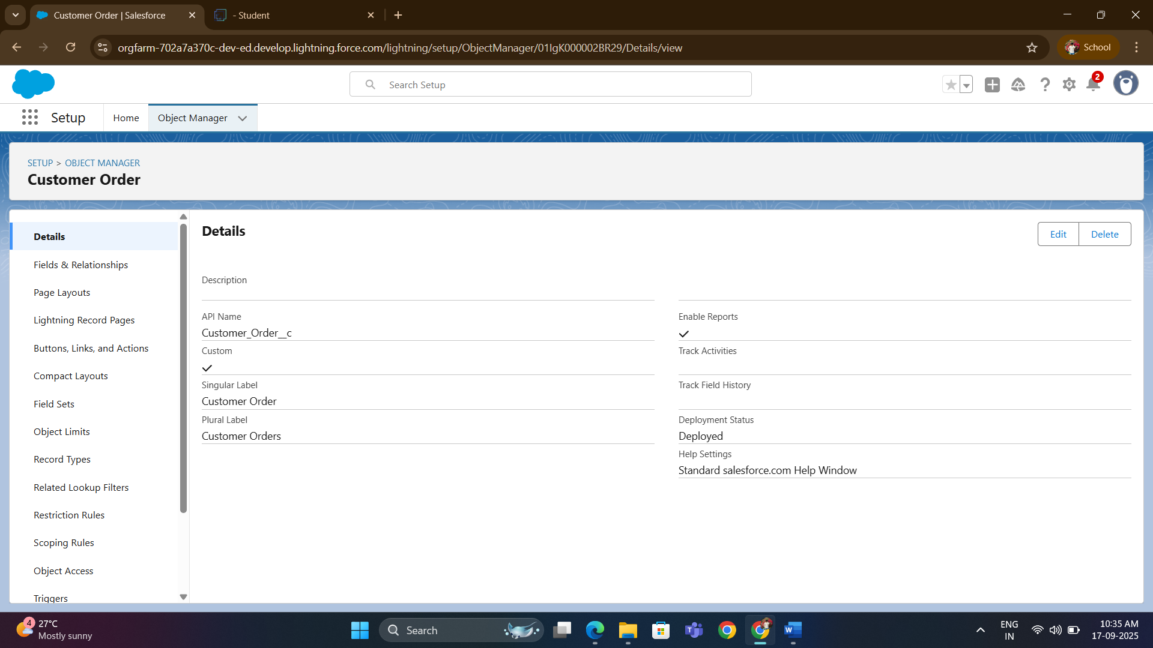

Item

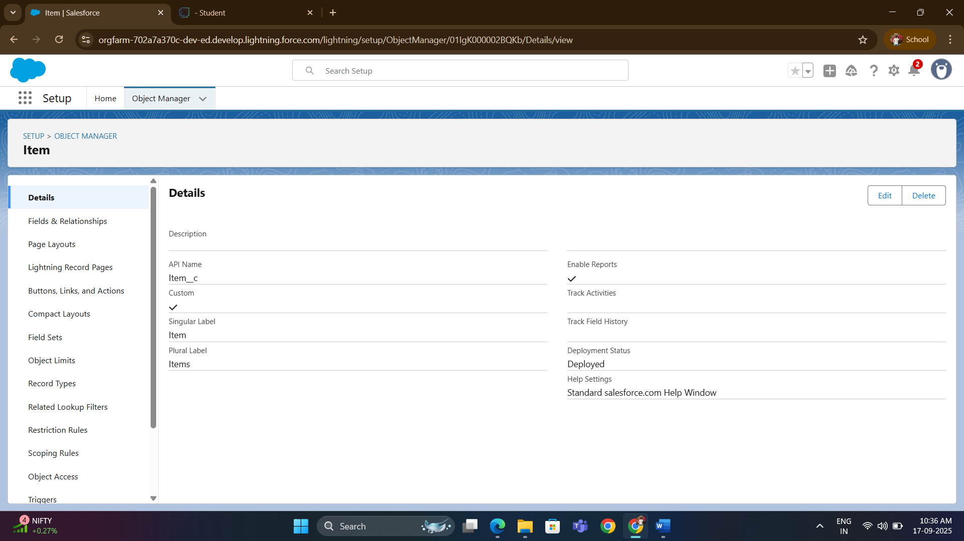

Price

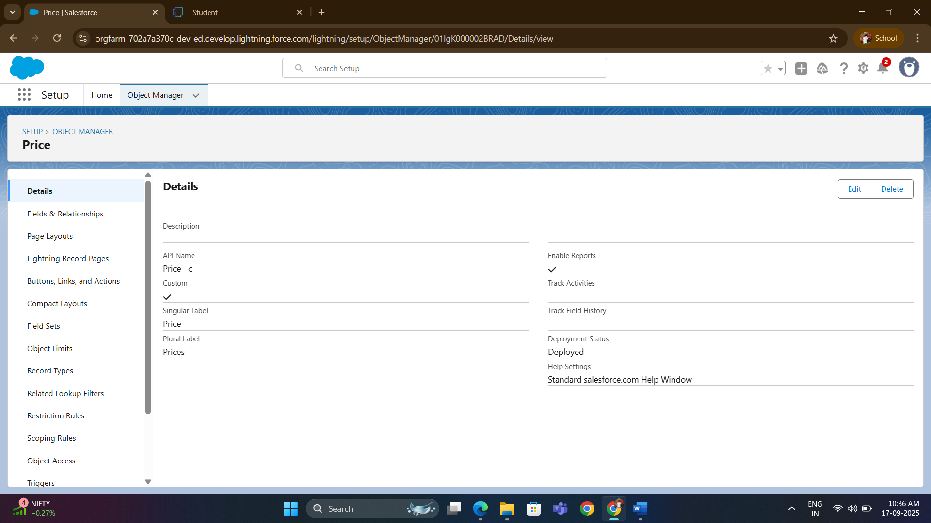

Billing

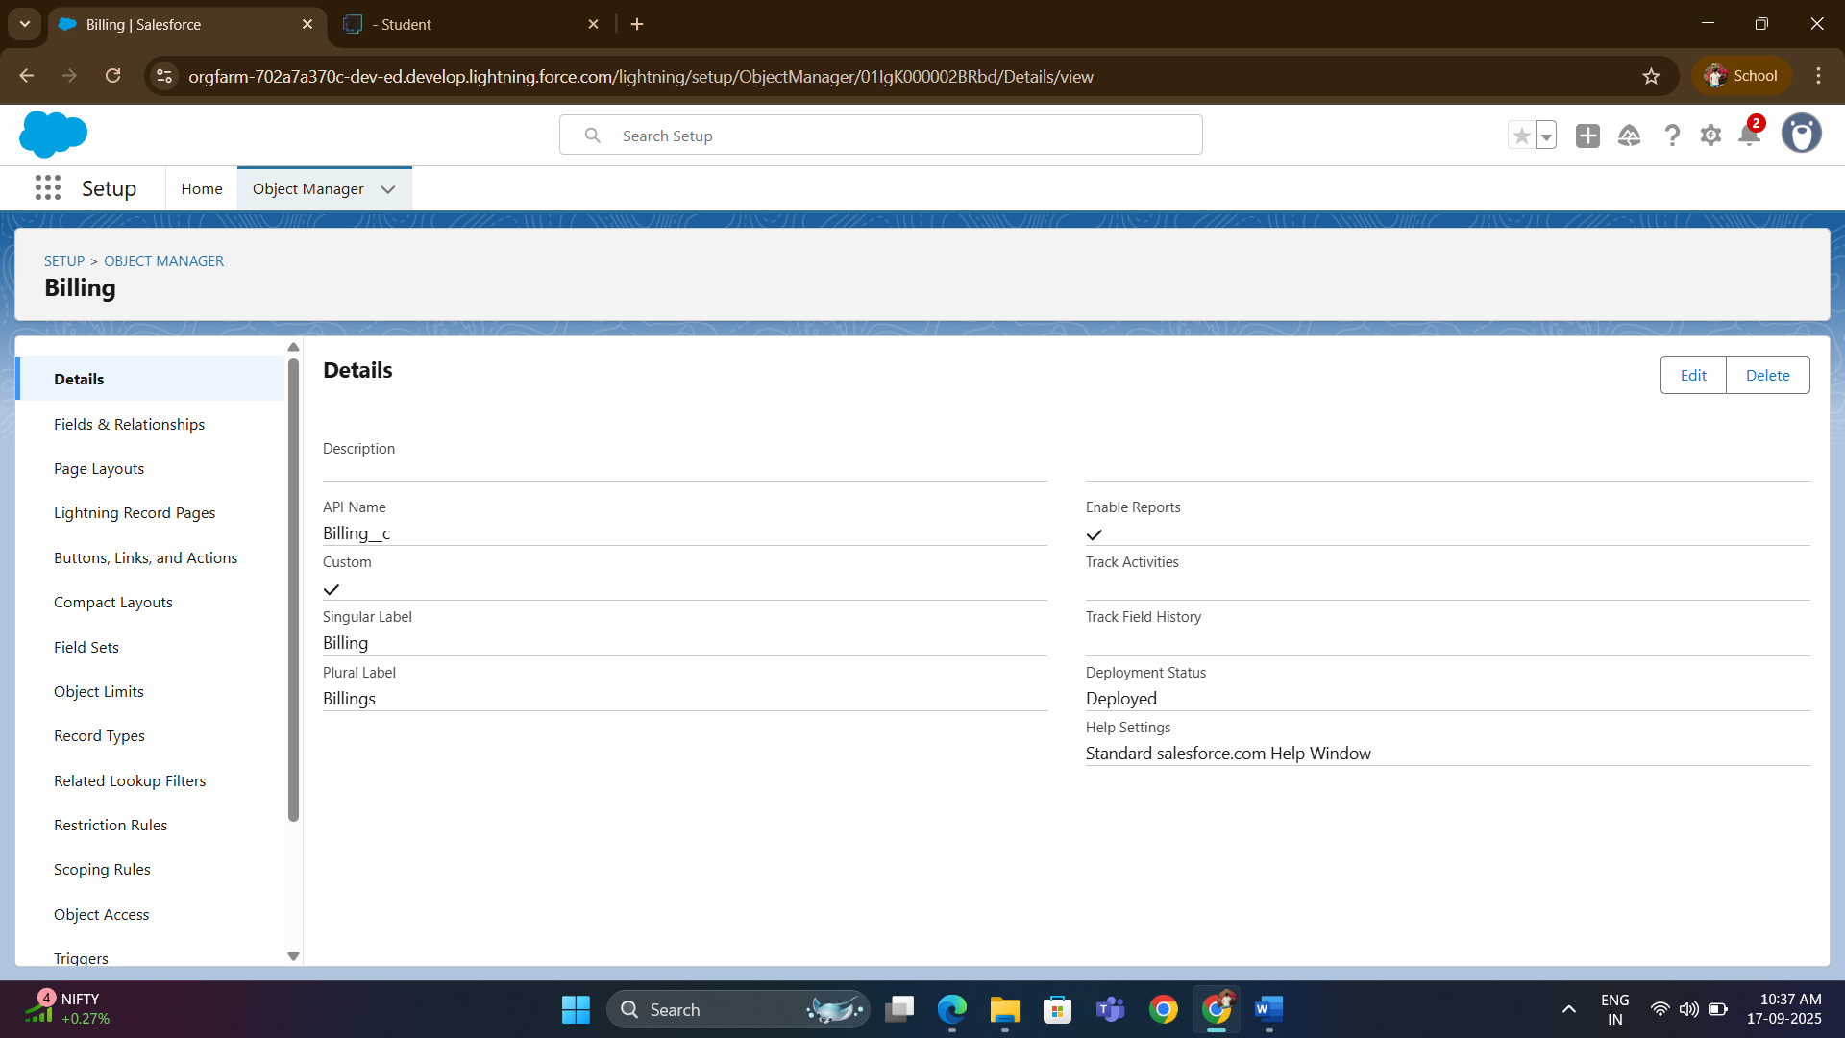

**Custom Tabs**

Billings, Customer Orders, Items, Jewel Customers, Prices

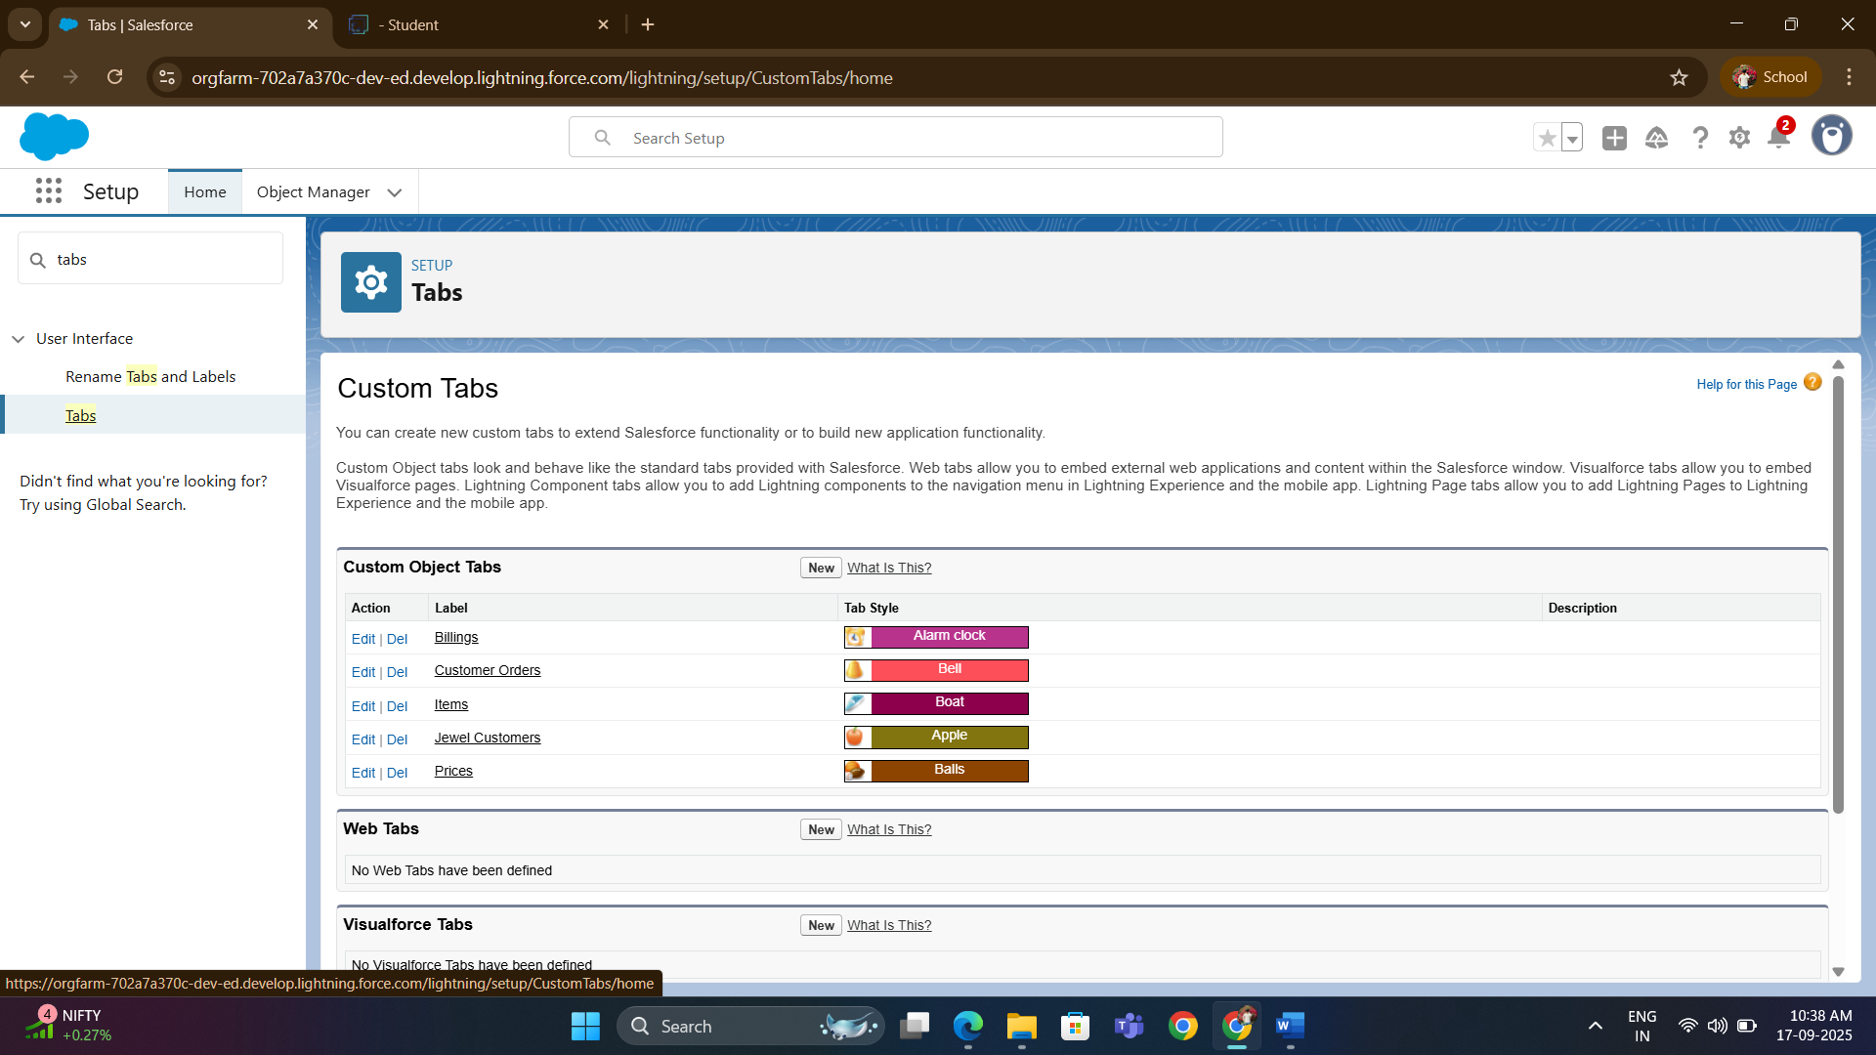

**Developing Lightning App with relevant tabs**

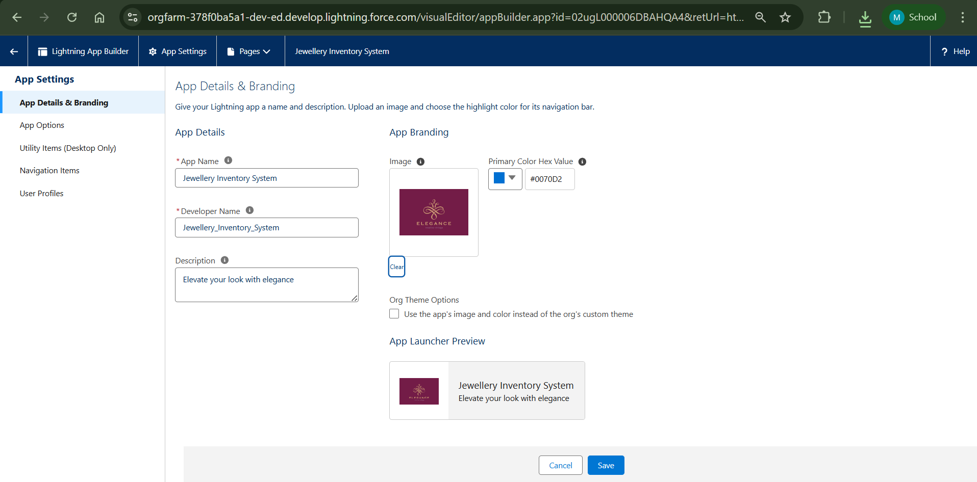

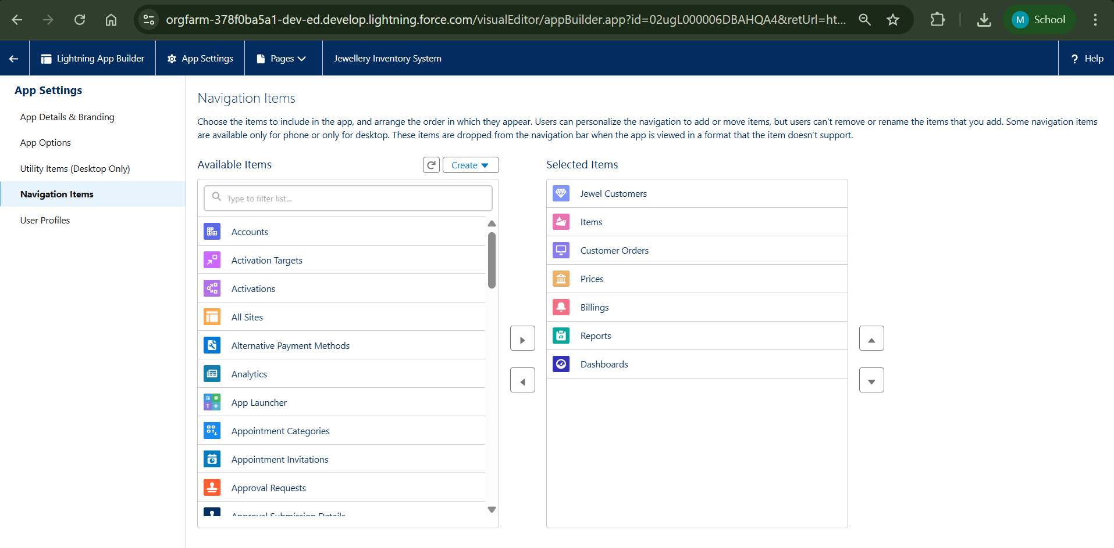

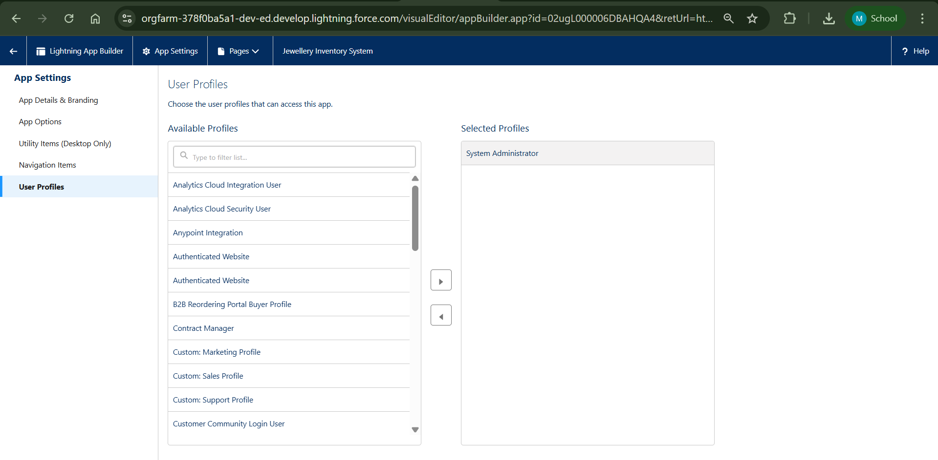

**Configure fields and relationships**

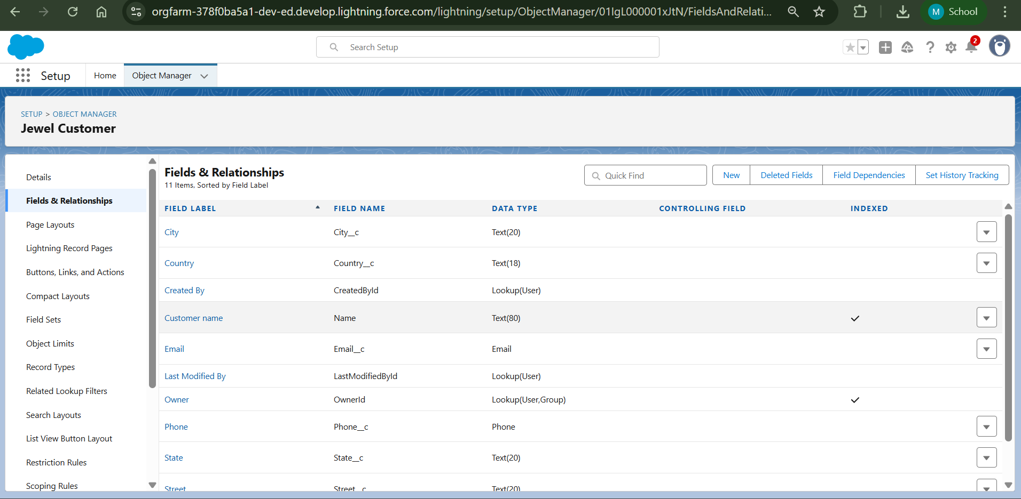

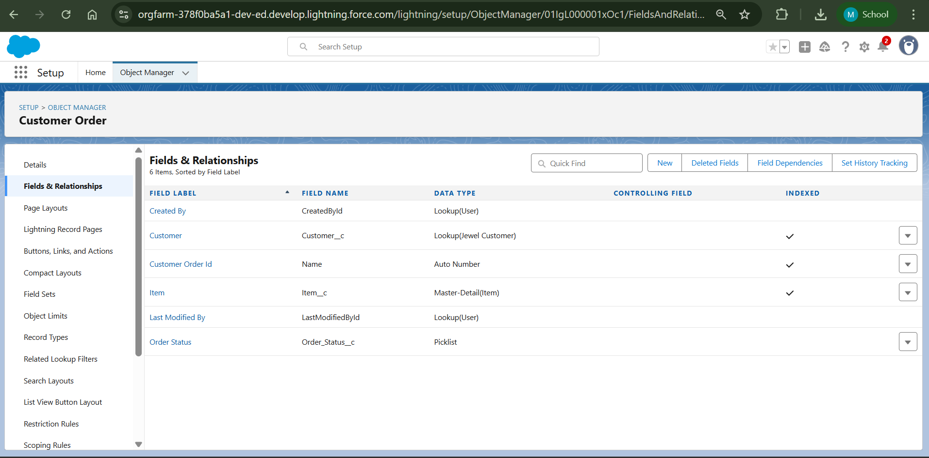

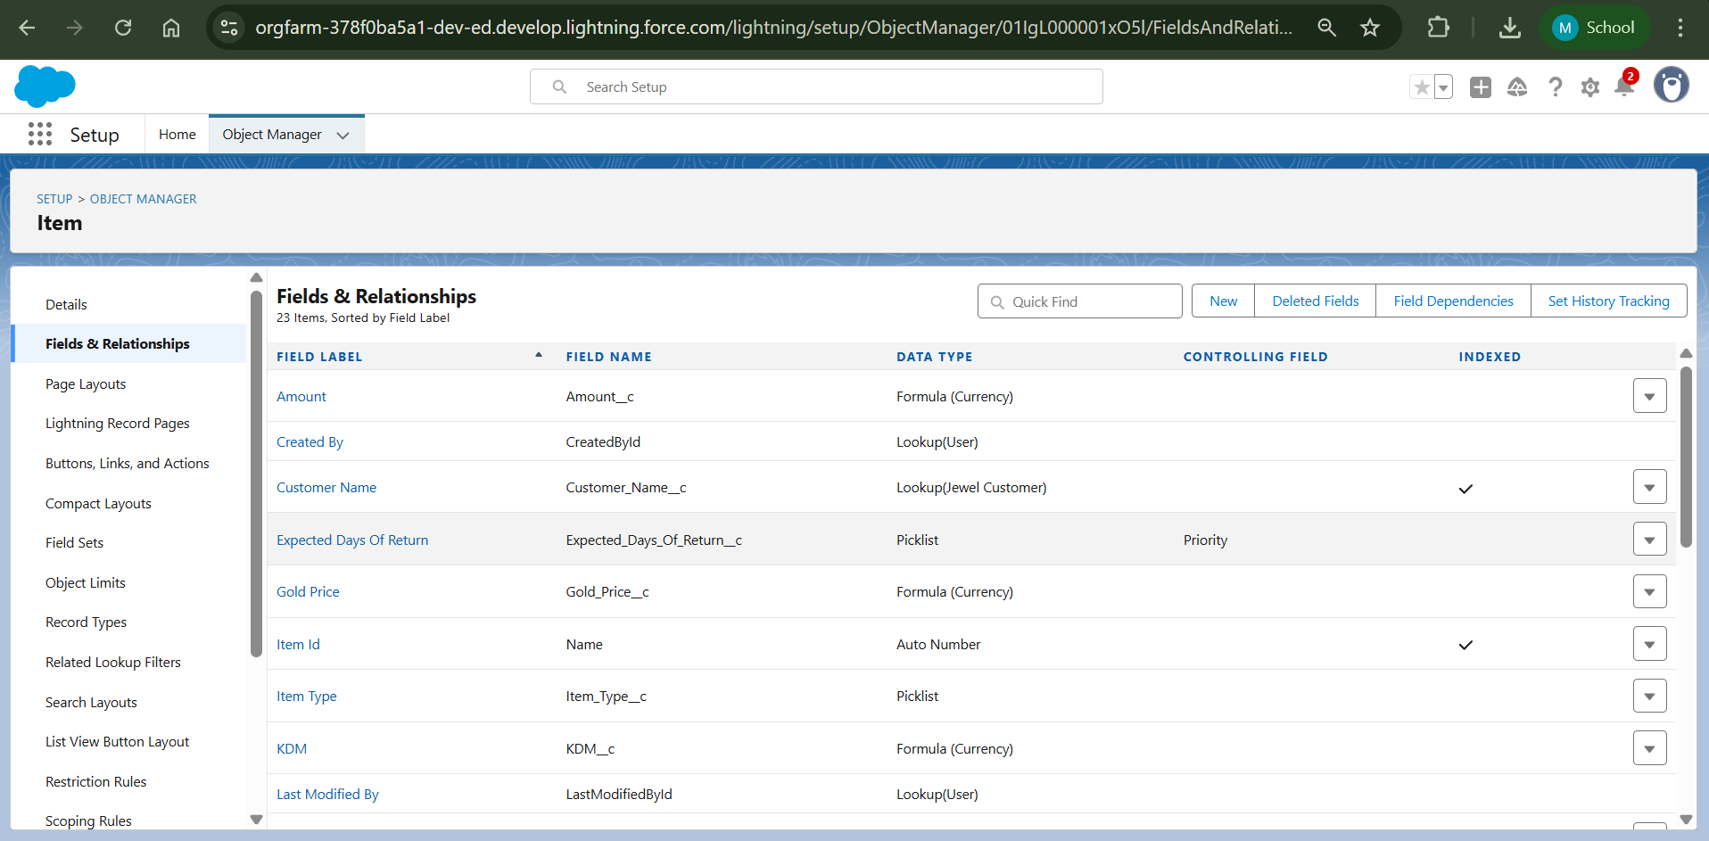

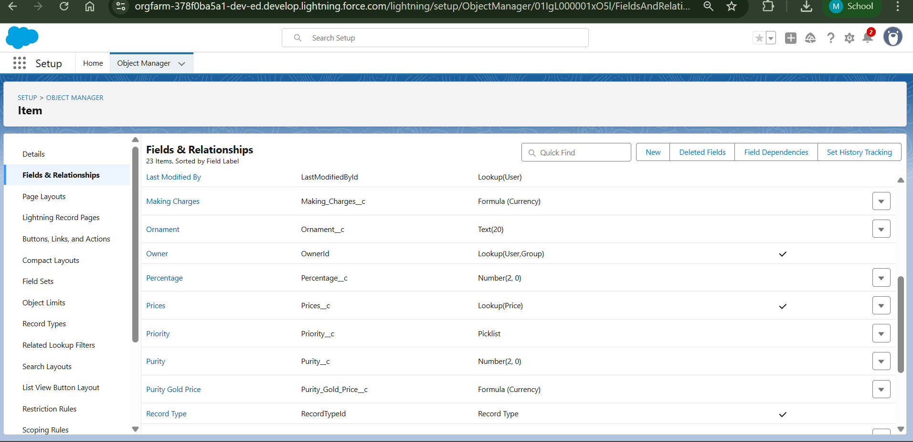

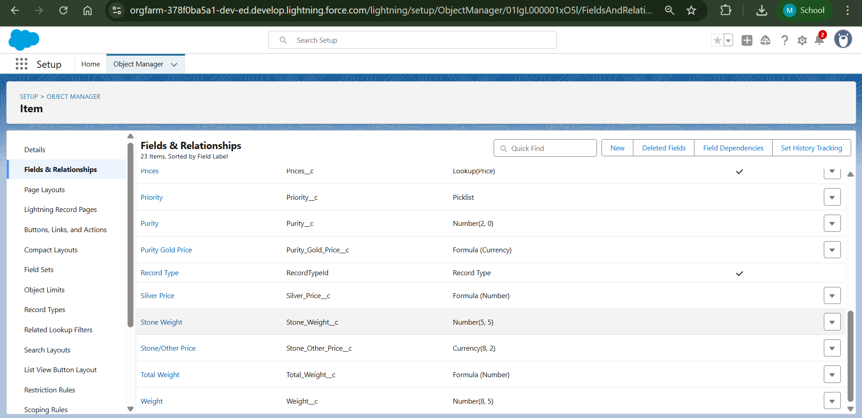

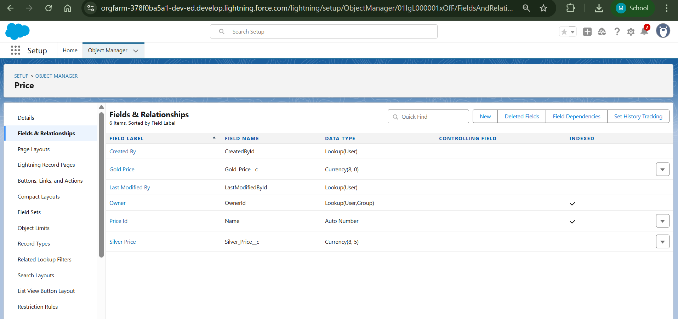

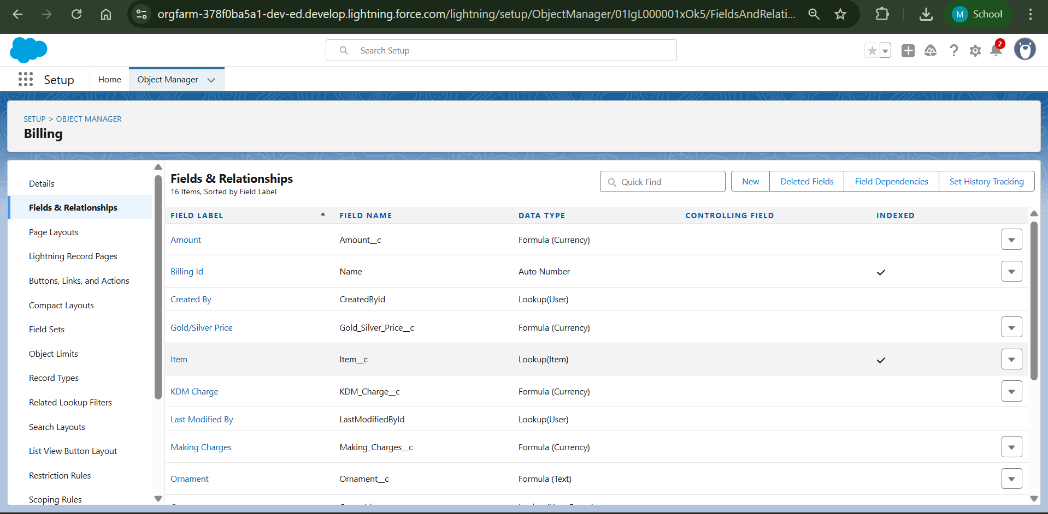

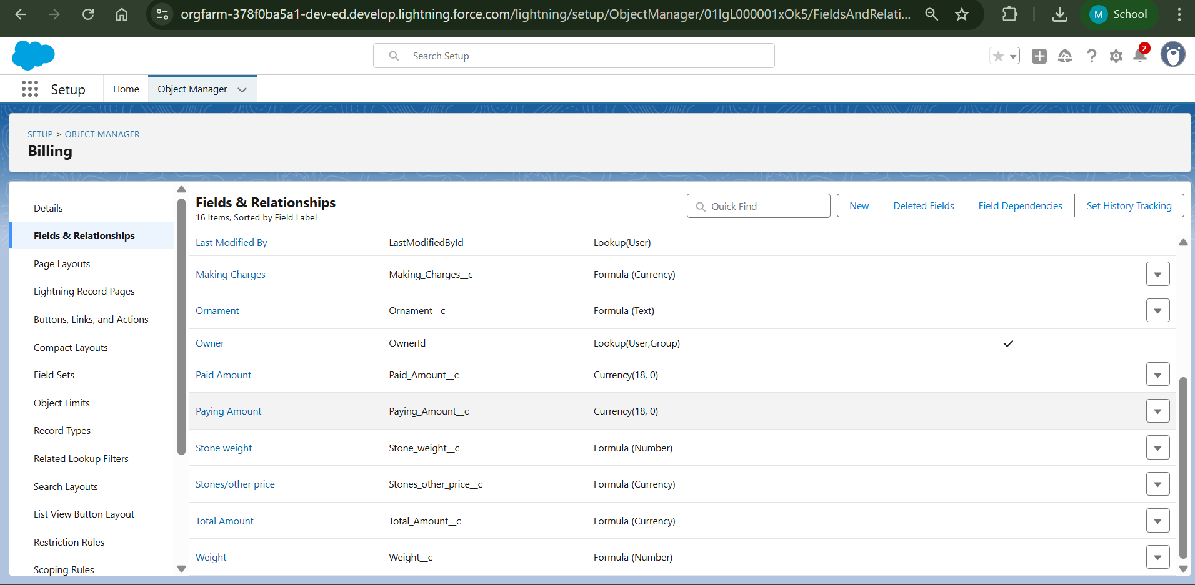

**Field Dependency**

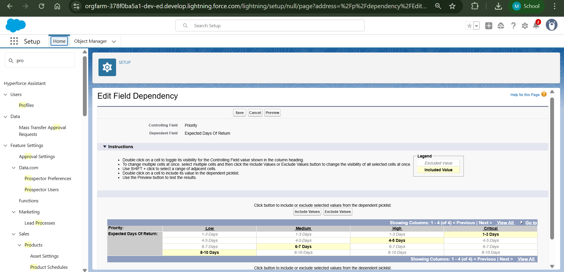

**Validation Rule**

Jewel Customer

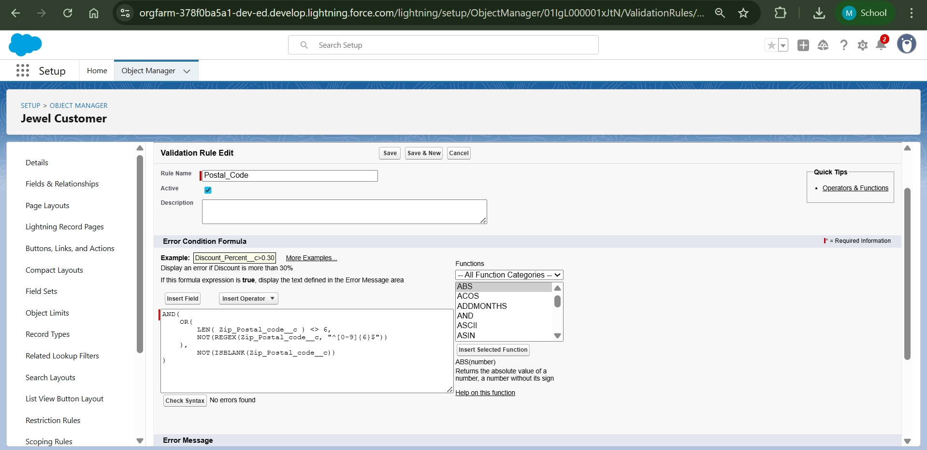

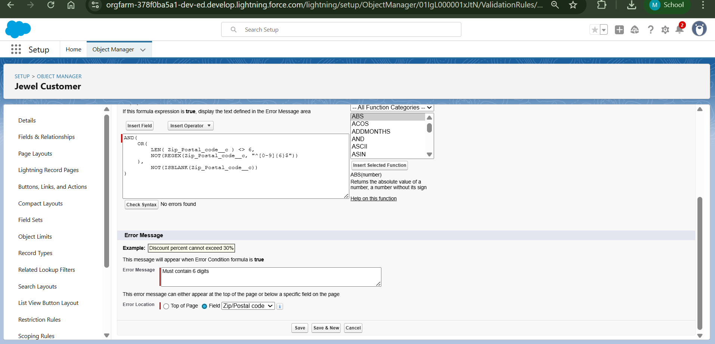

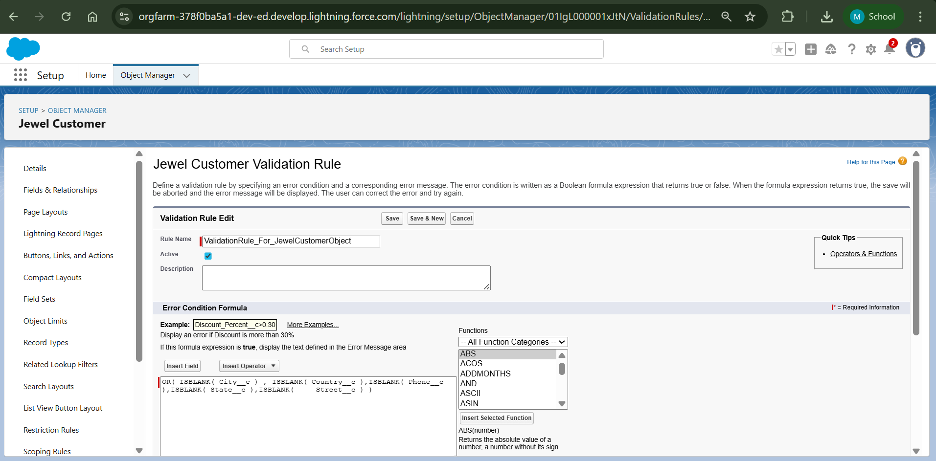

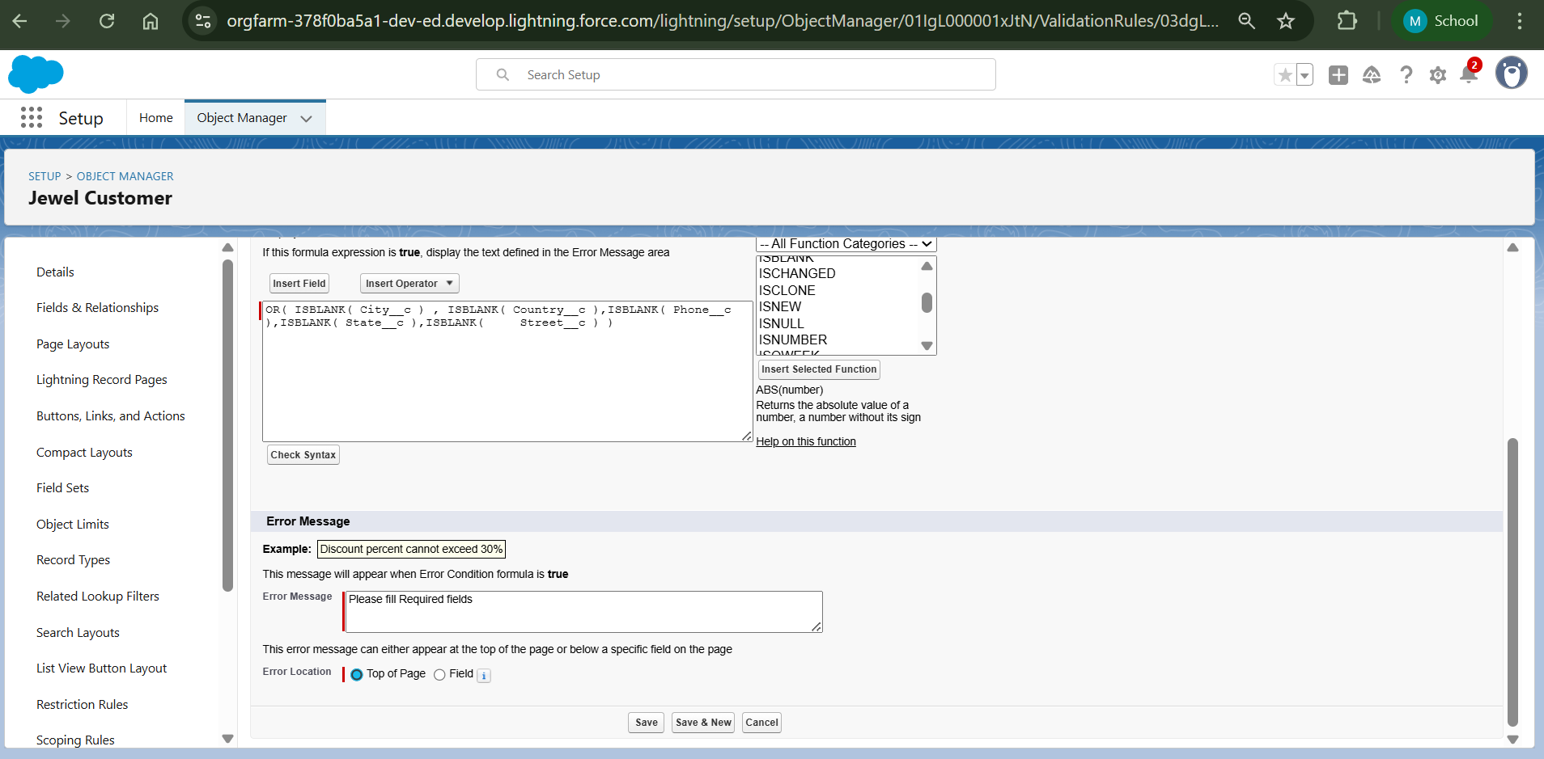

Item

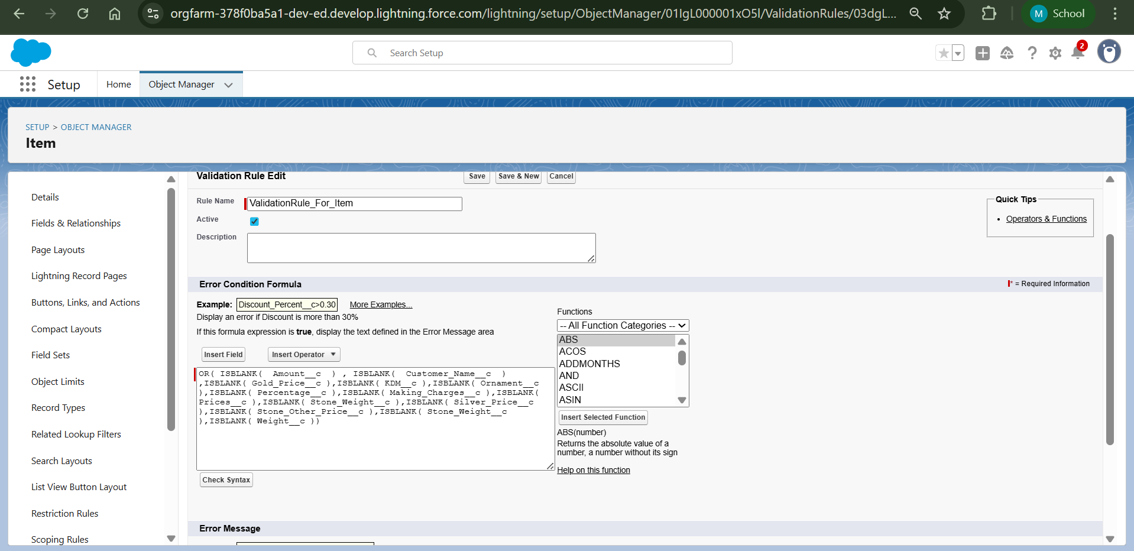

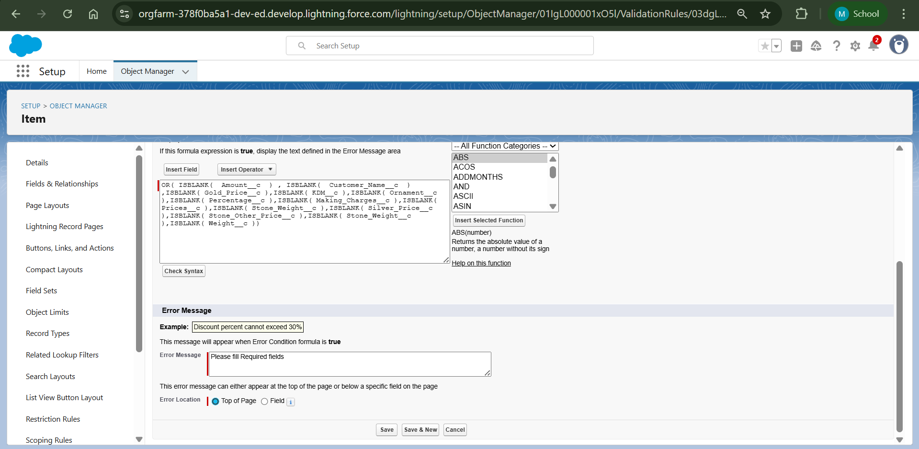

**Profiles**

Gold smith

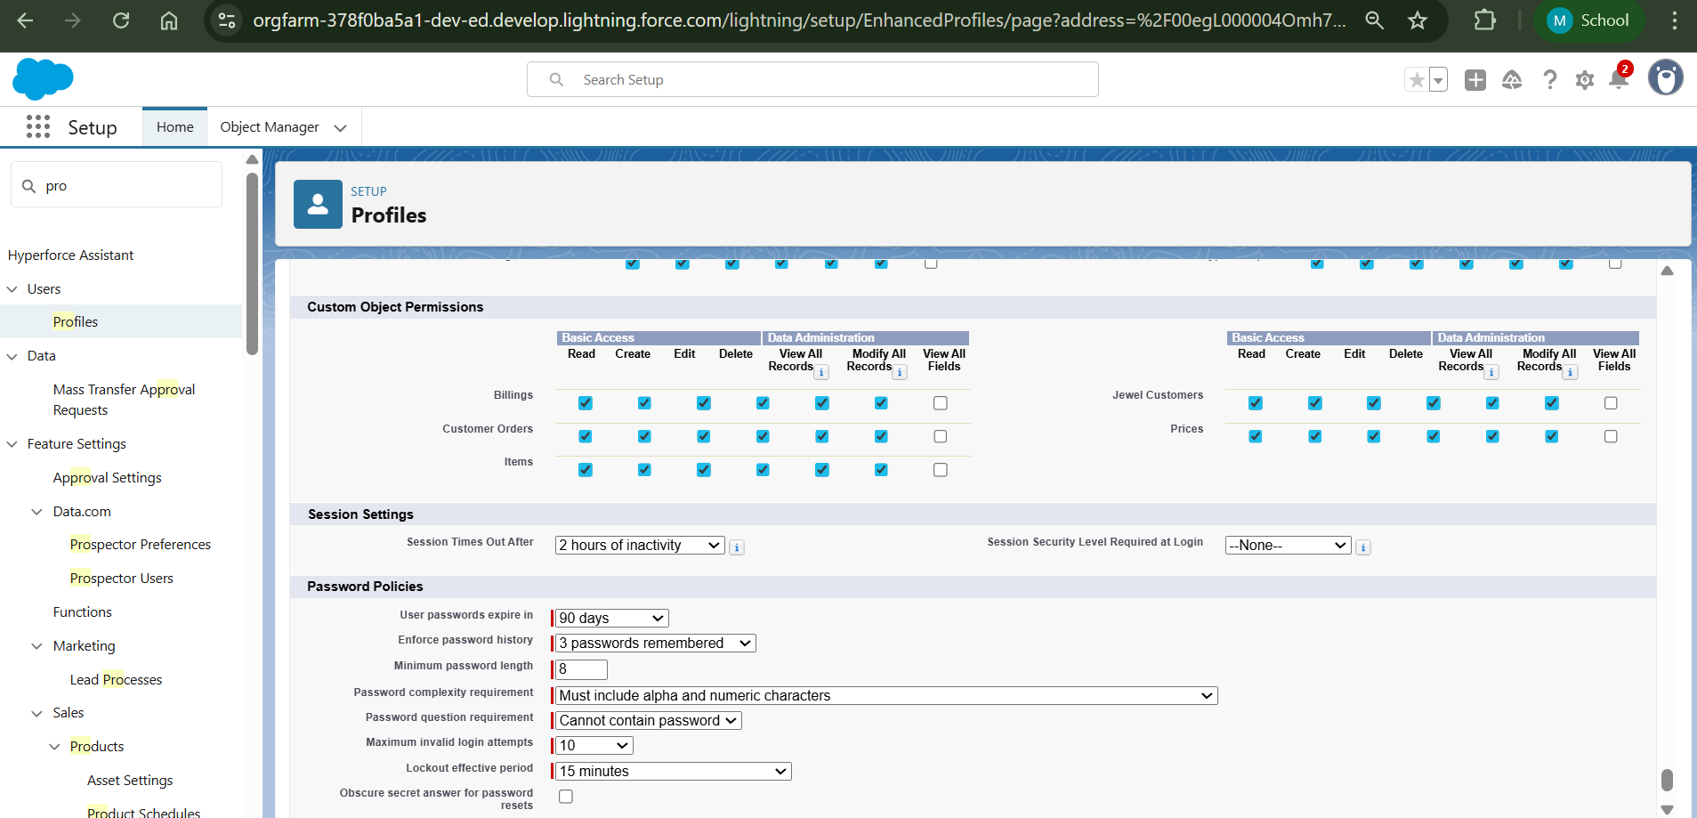

Worker

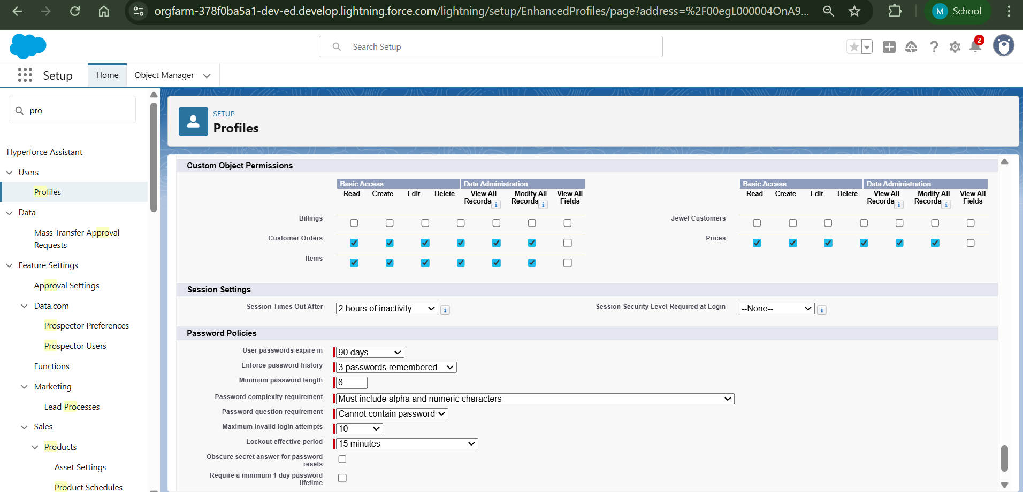

**Roles**

Gold Smith and Worker

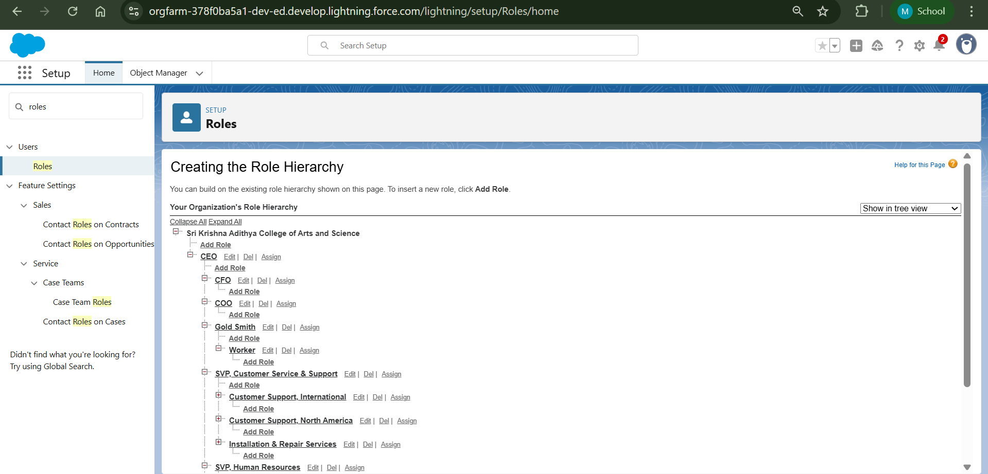

**Created Users**

Gold Smith

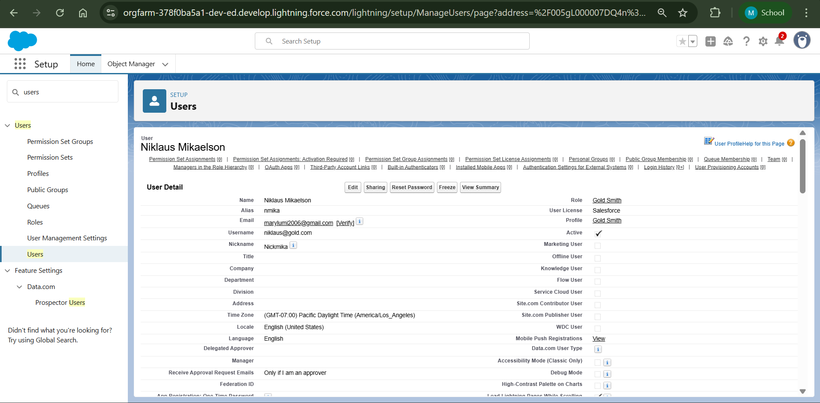

Worker

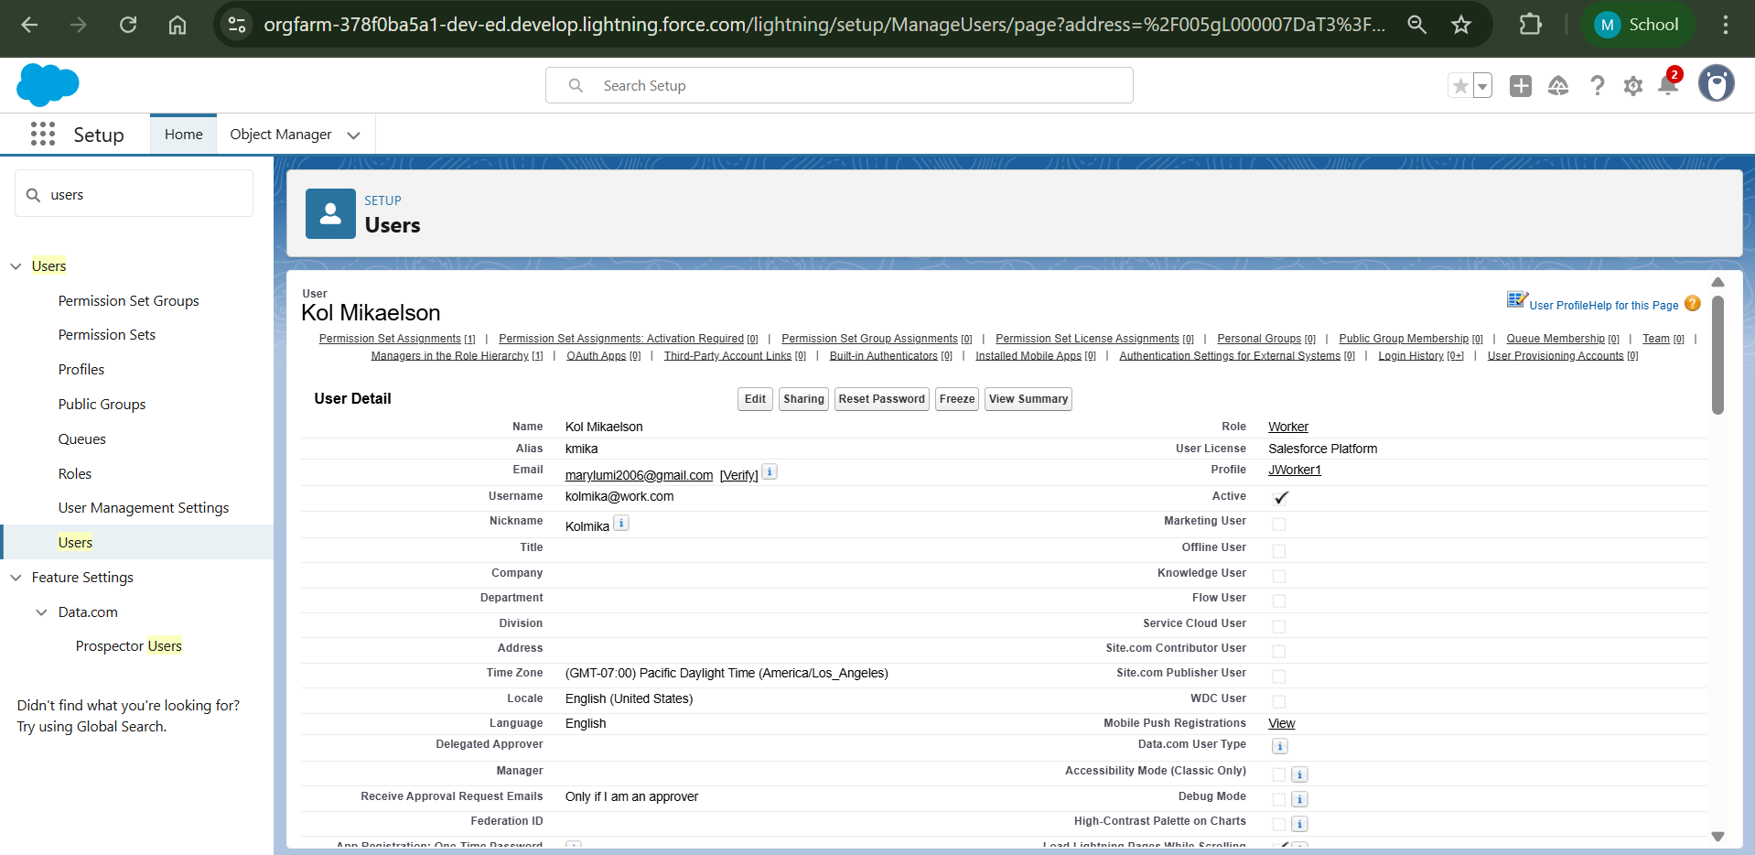

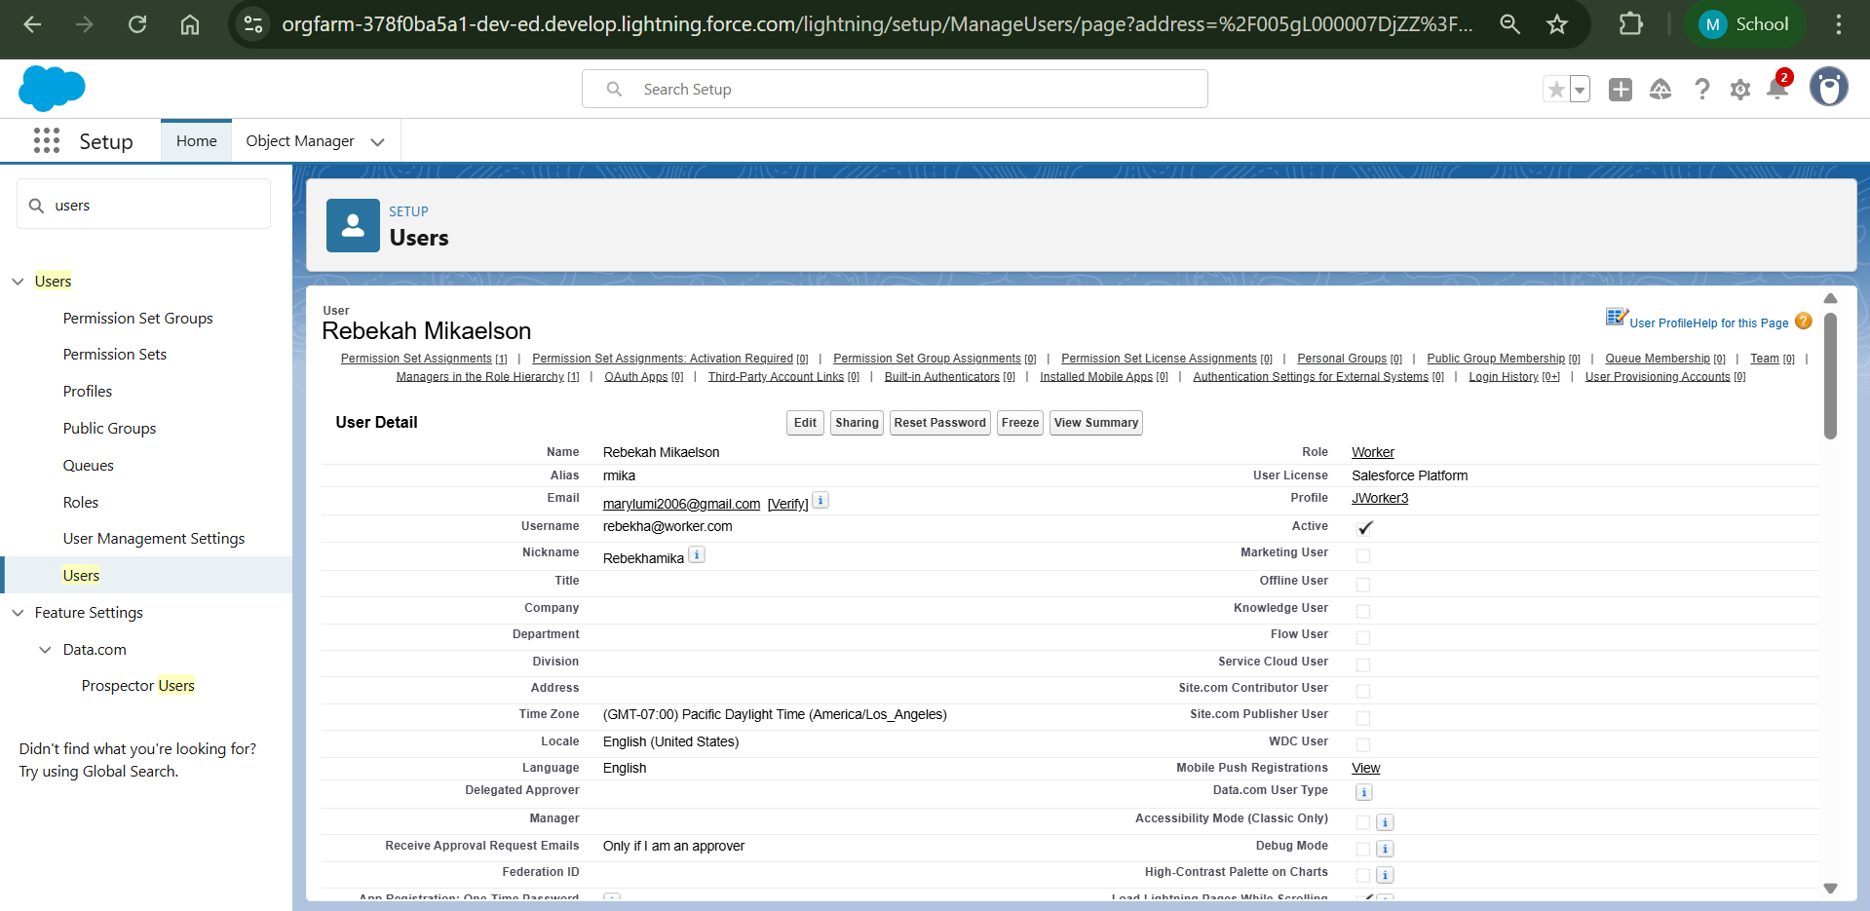

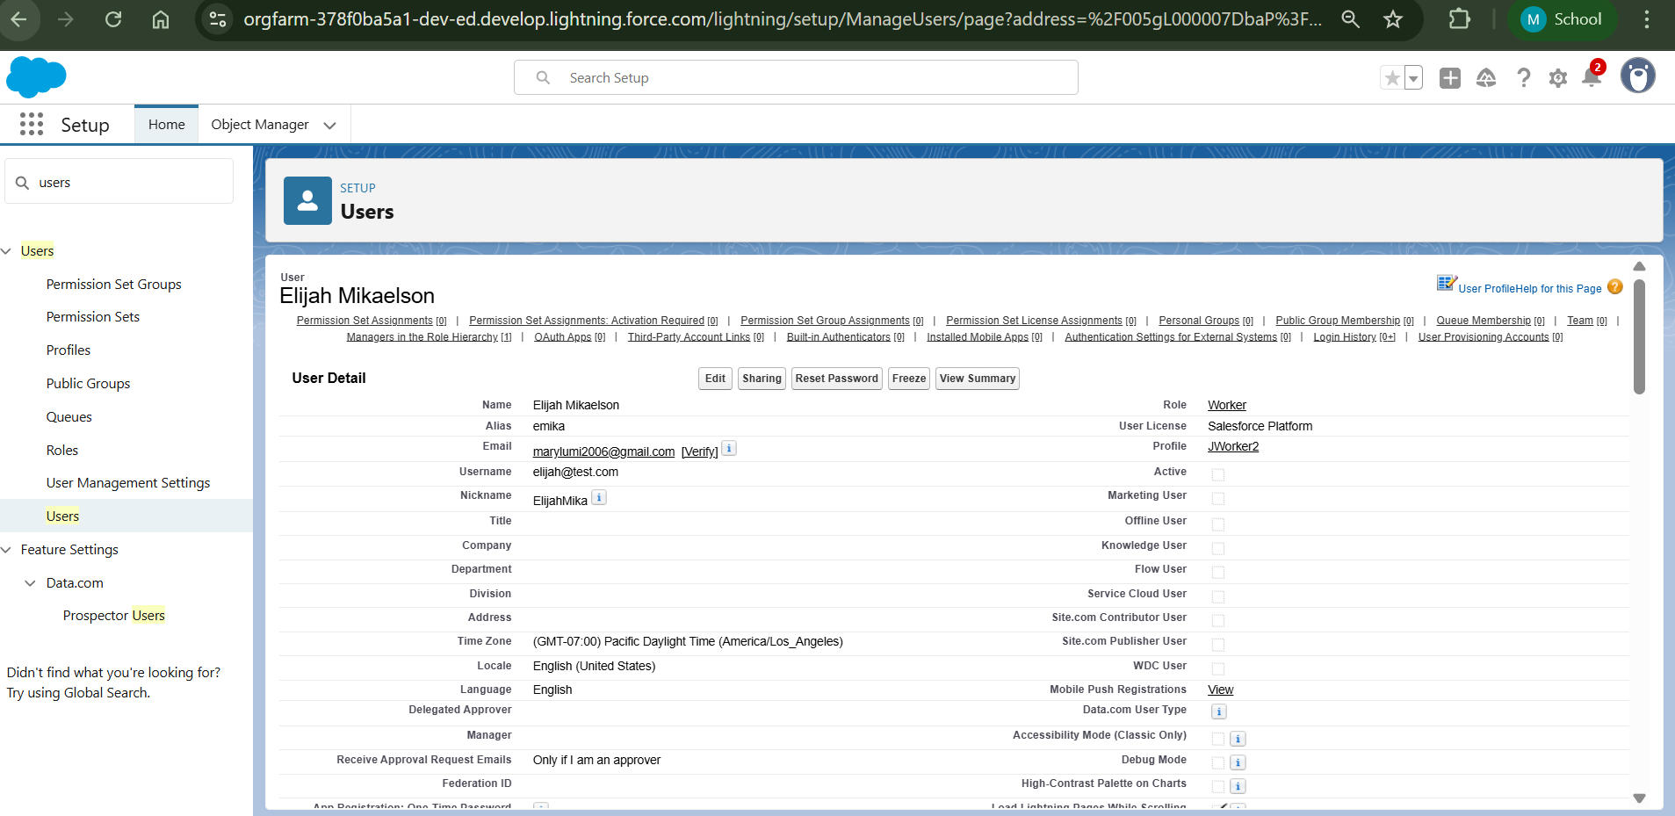

**Page Layout**

Gold Page Layout

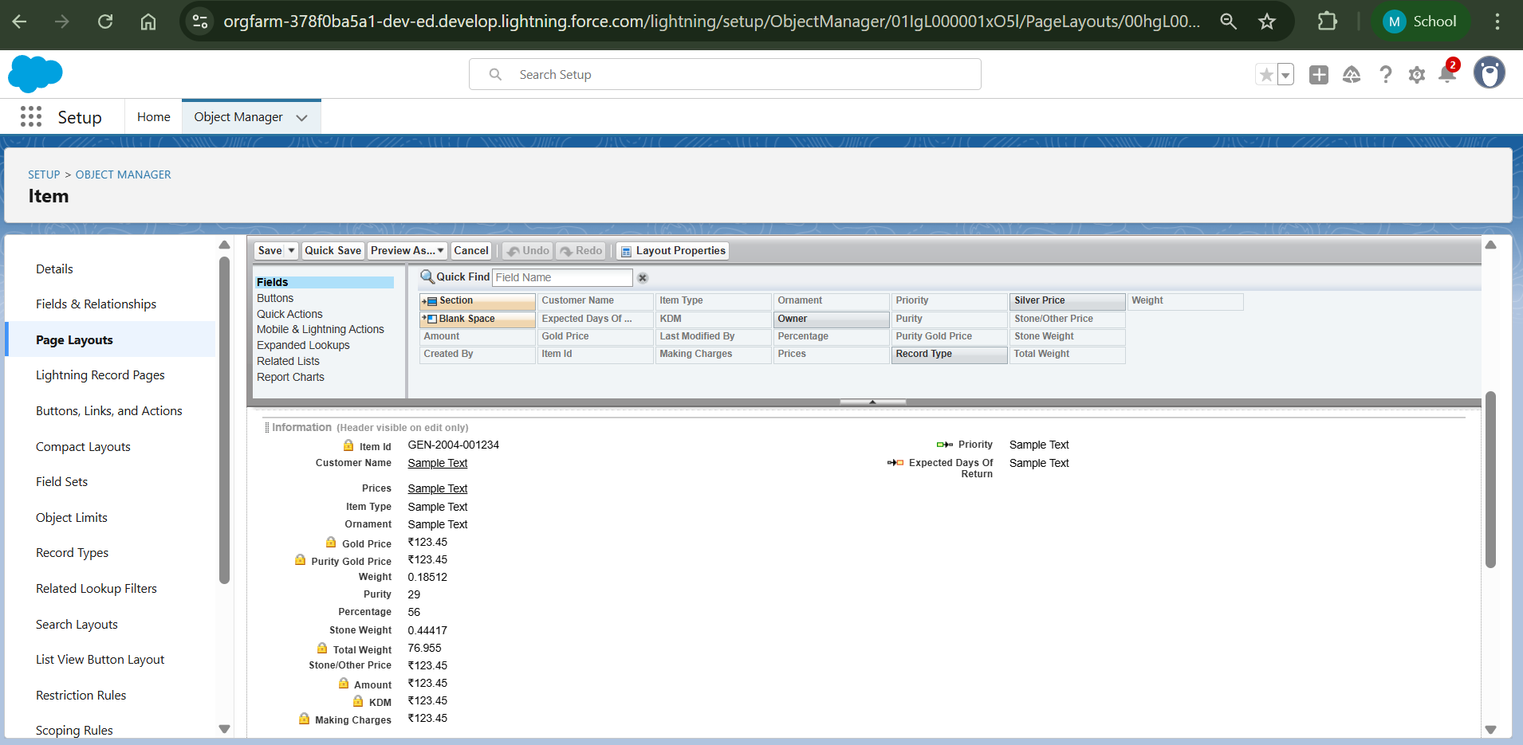

Silver Page Layout

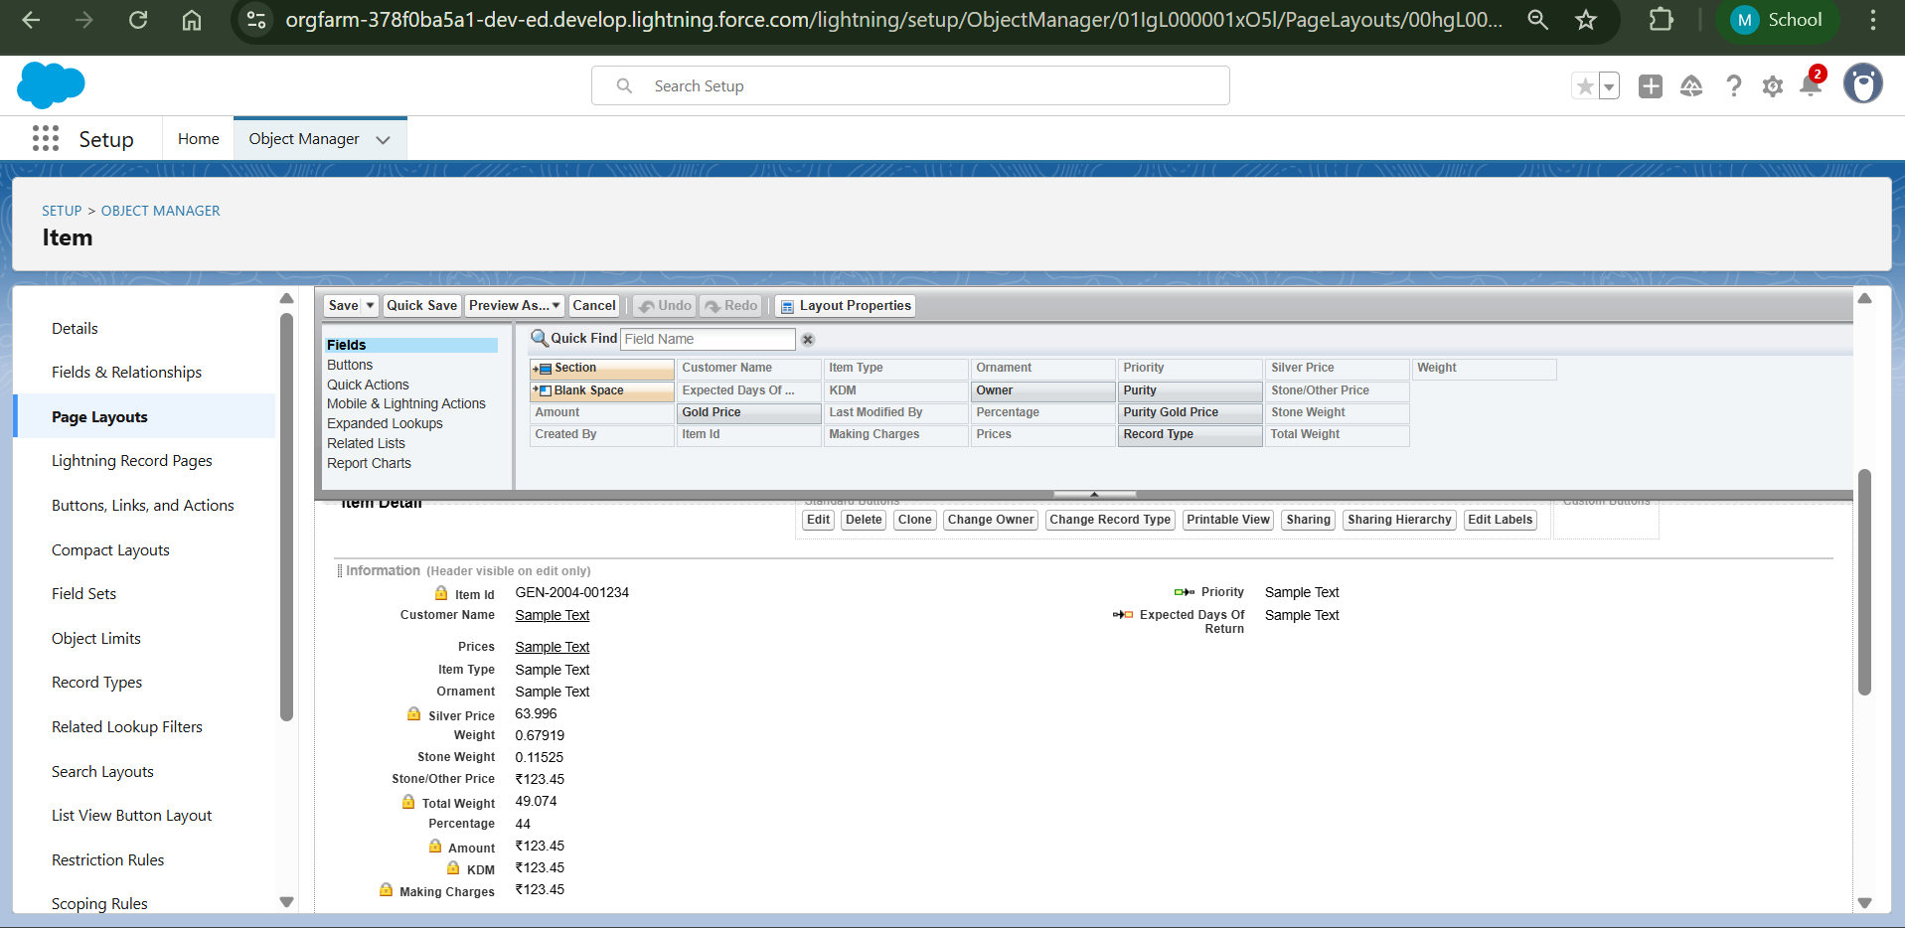

Record Types

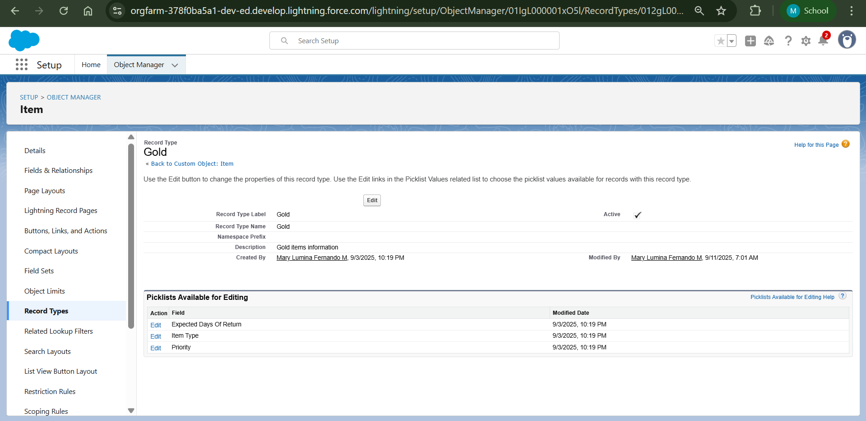

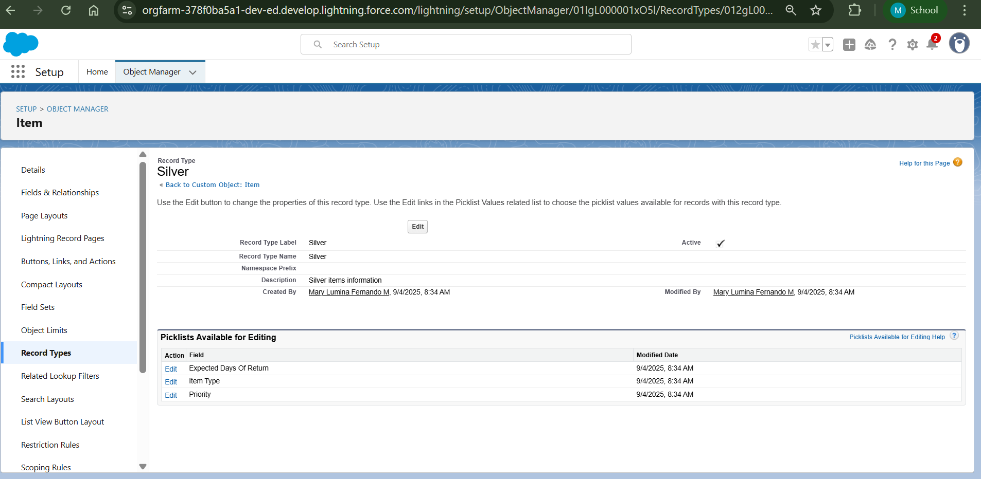

**Permission Sets**

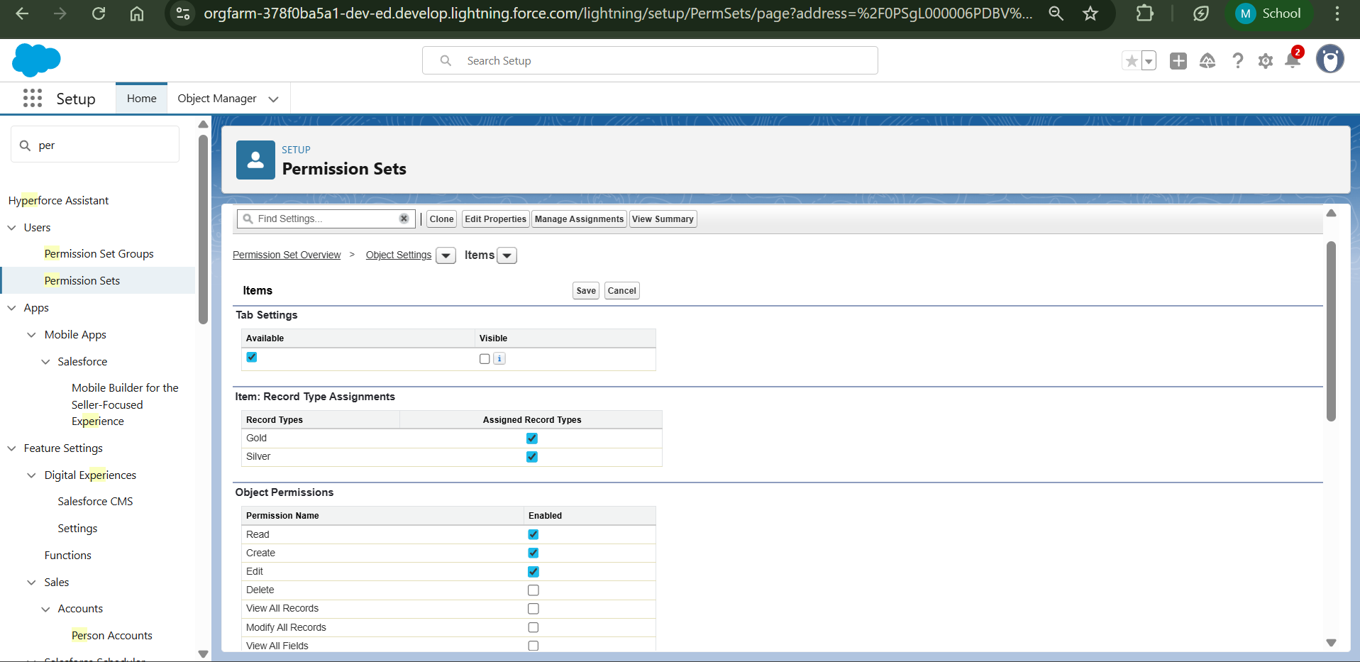

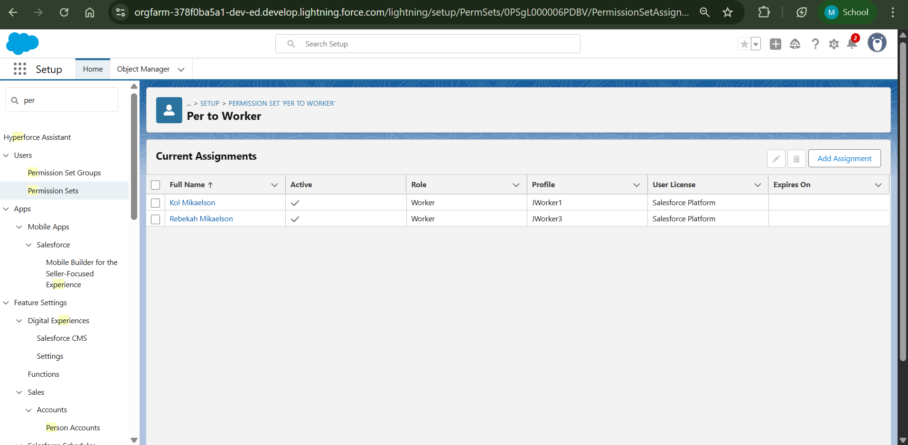

**Creating Apex Trigger handler Class**

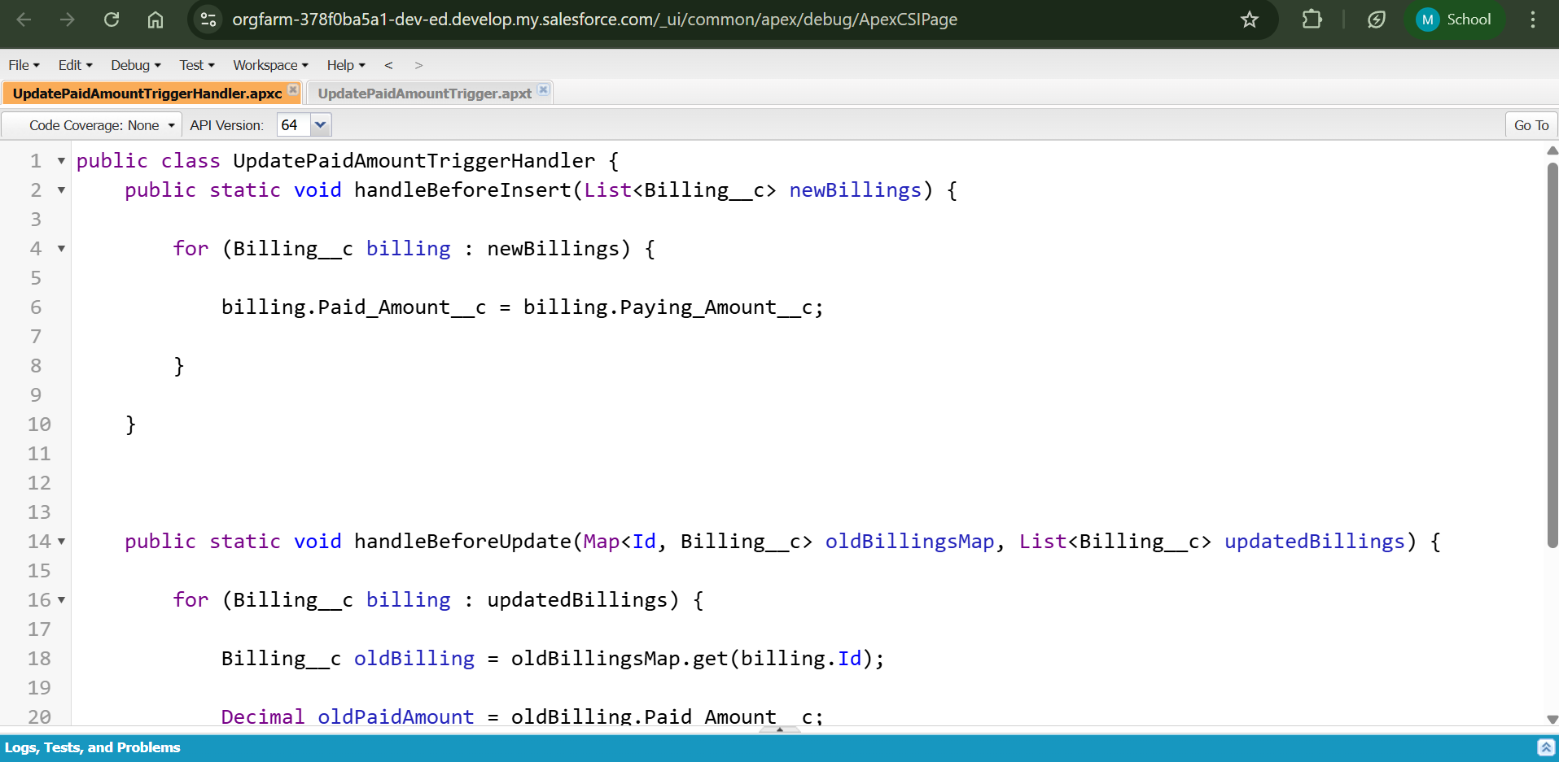

**Creating Apex Trigger**

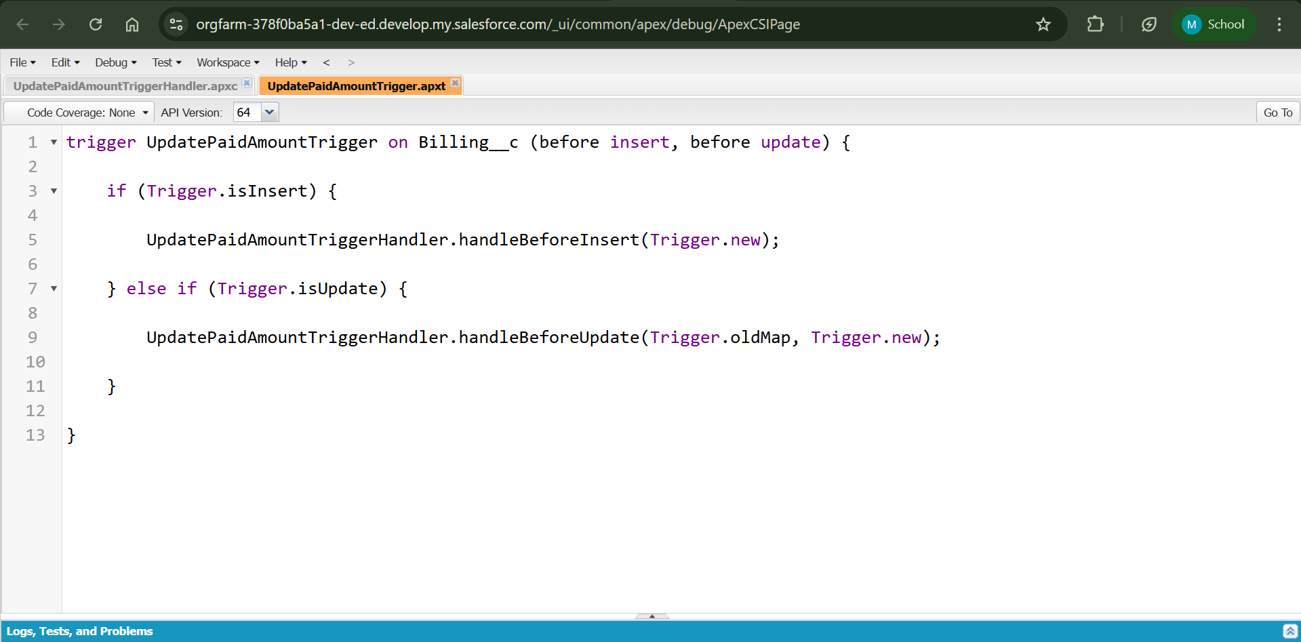

**Created Records**

Jewel Customers

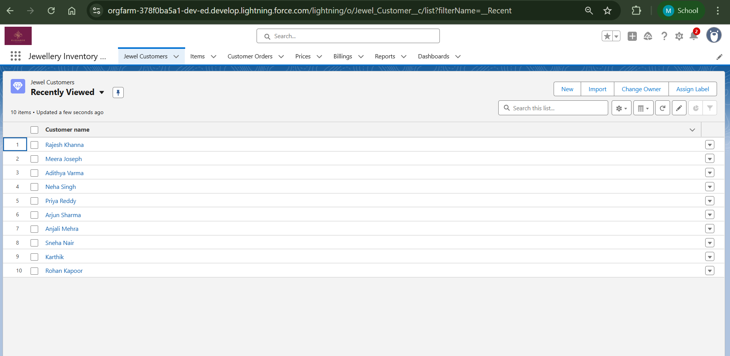

Items

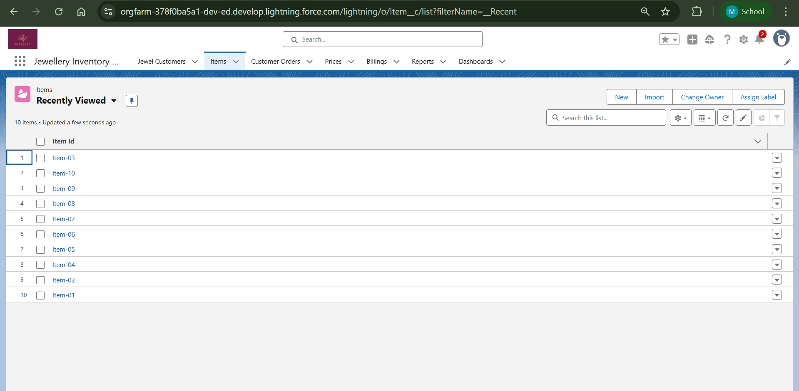

Customer Orders

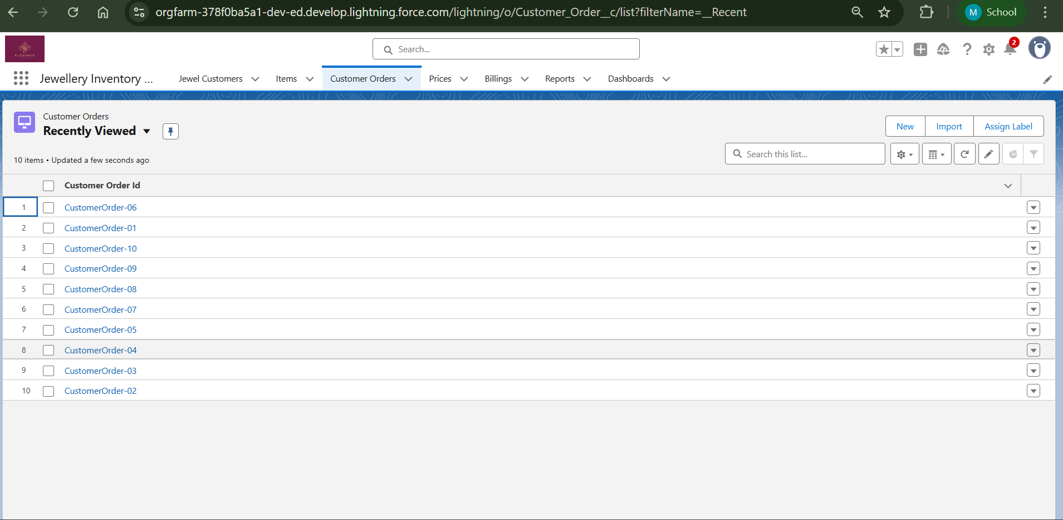

Prices

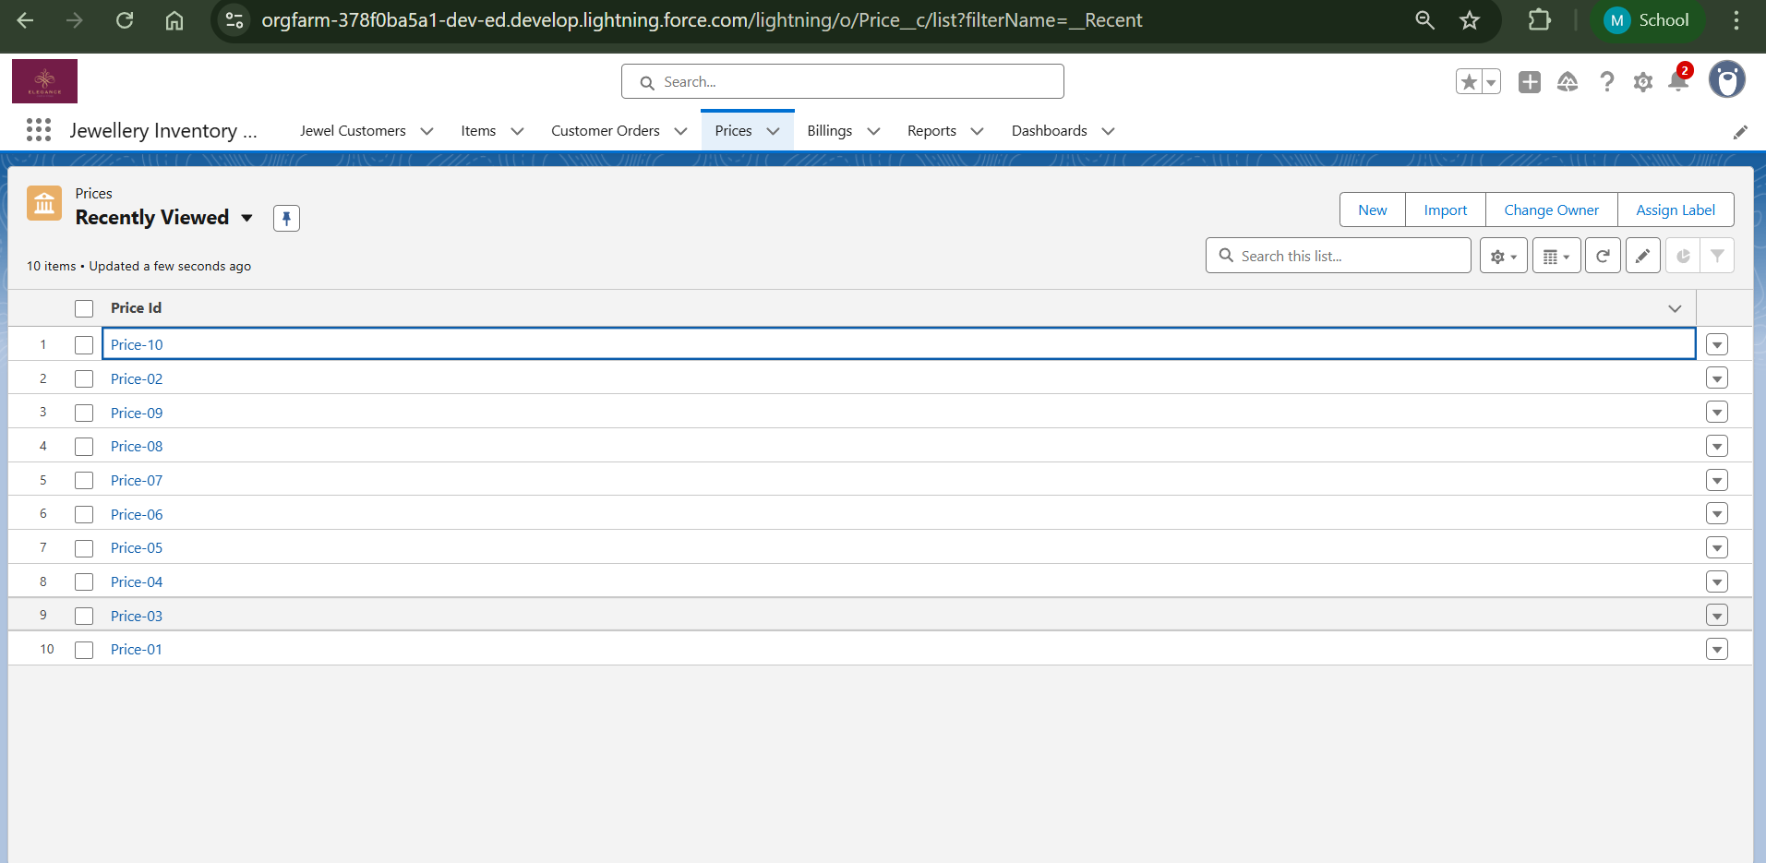

Billings

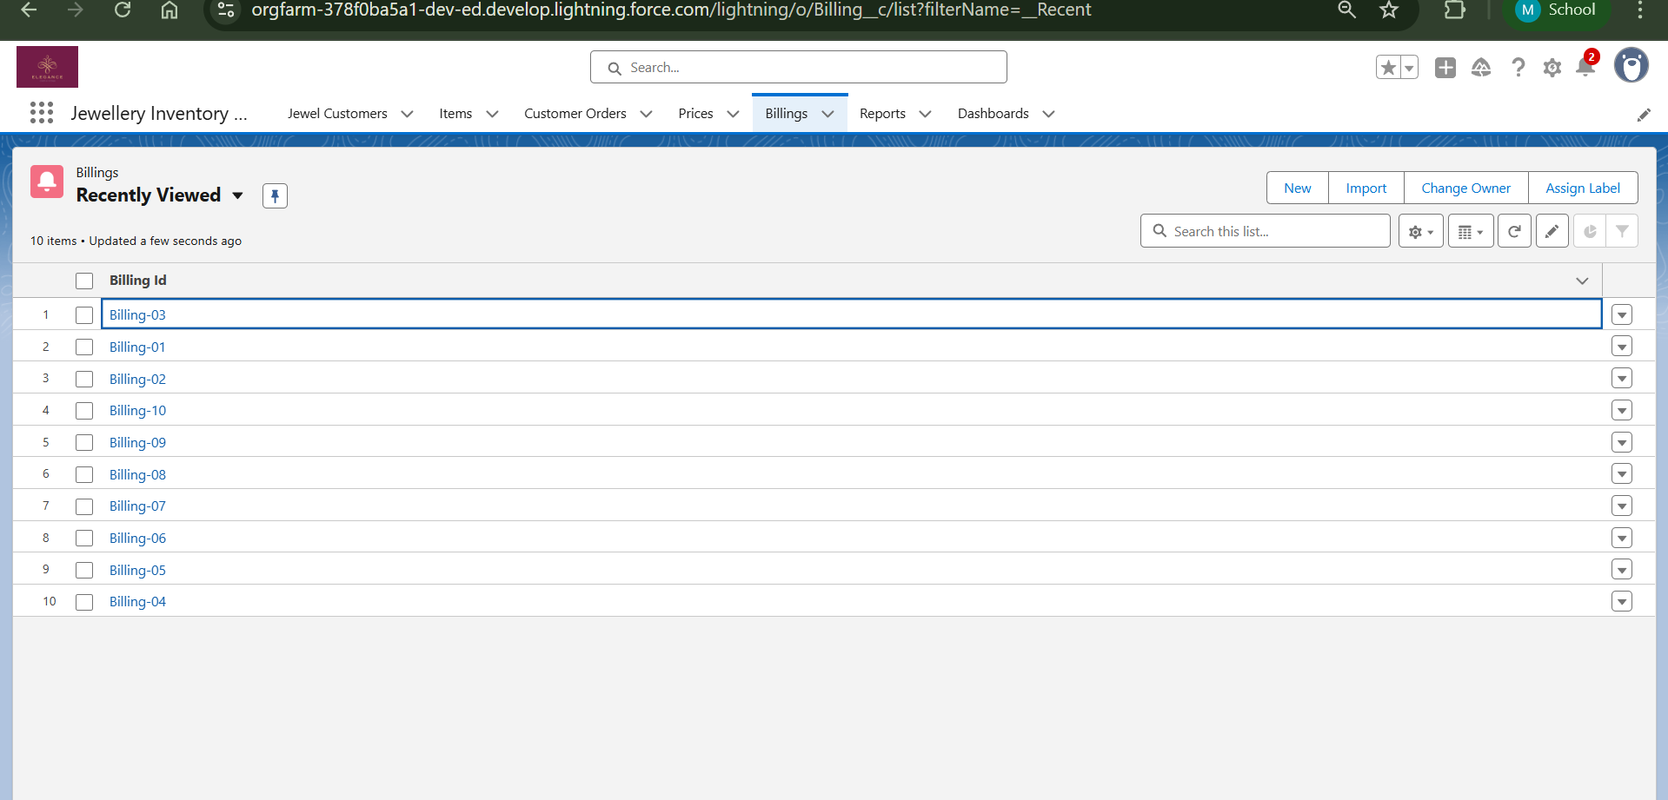

**Created Reports**

Reports

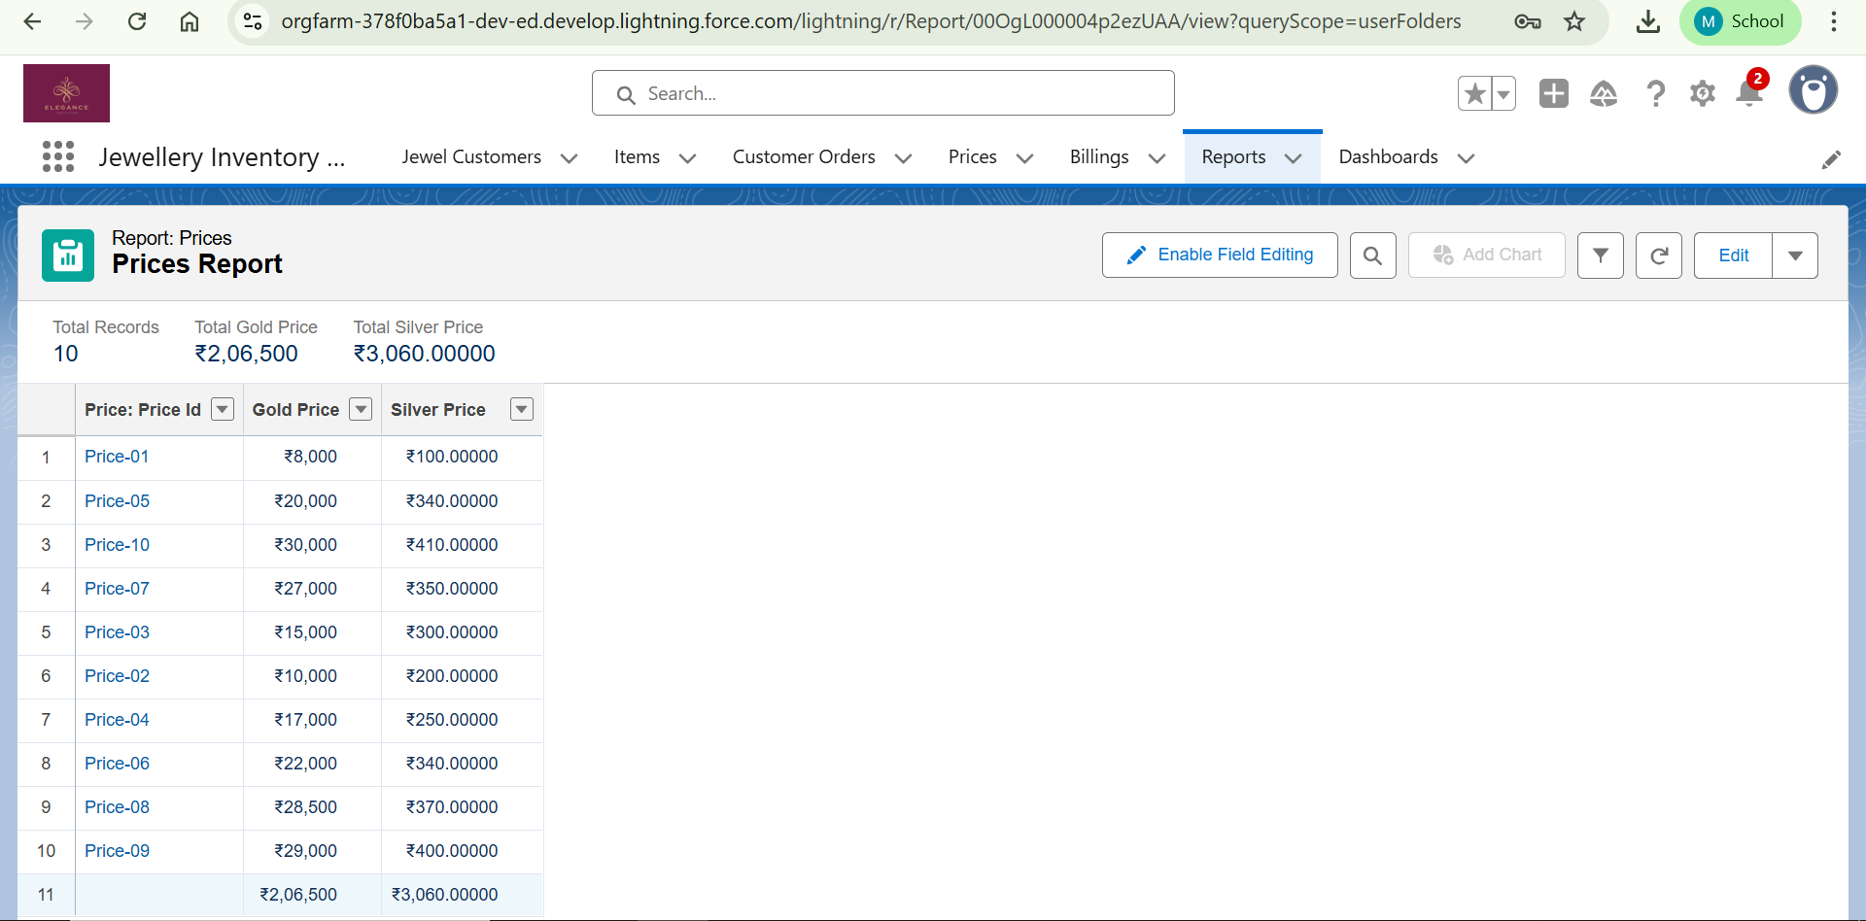

Billings with Items and Customer Orders

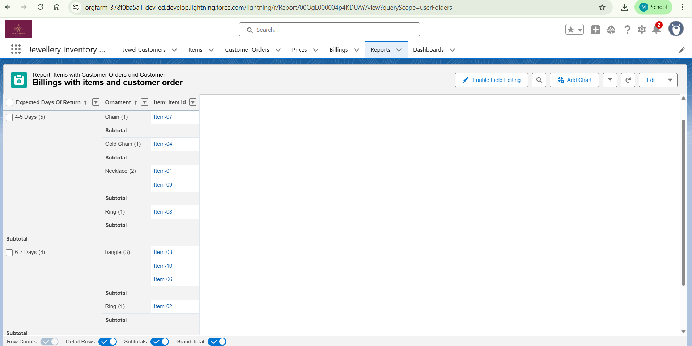

Items with Billings

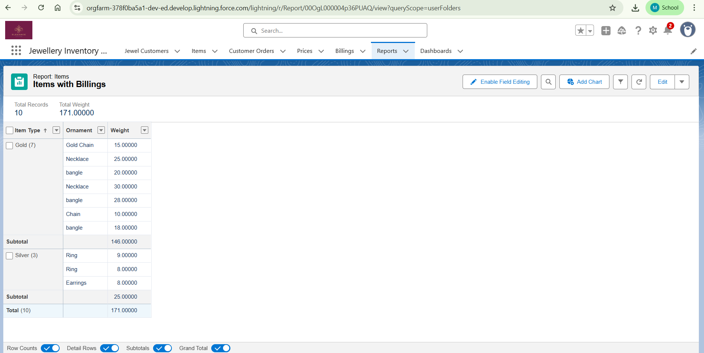

**Created Dashboard**

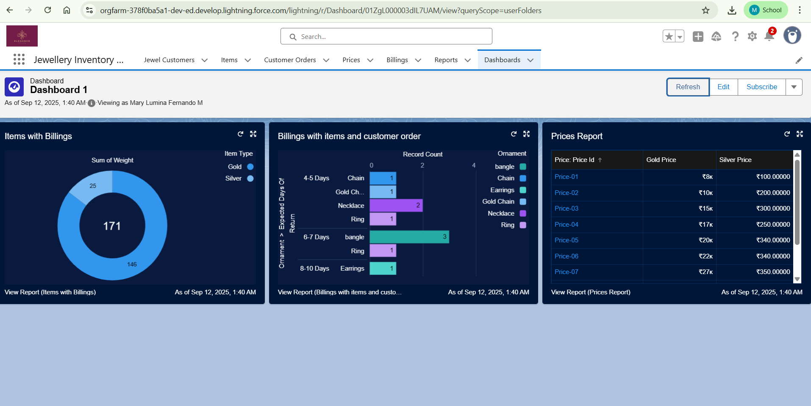

**Created Flow**

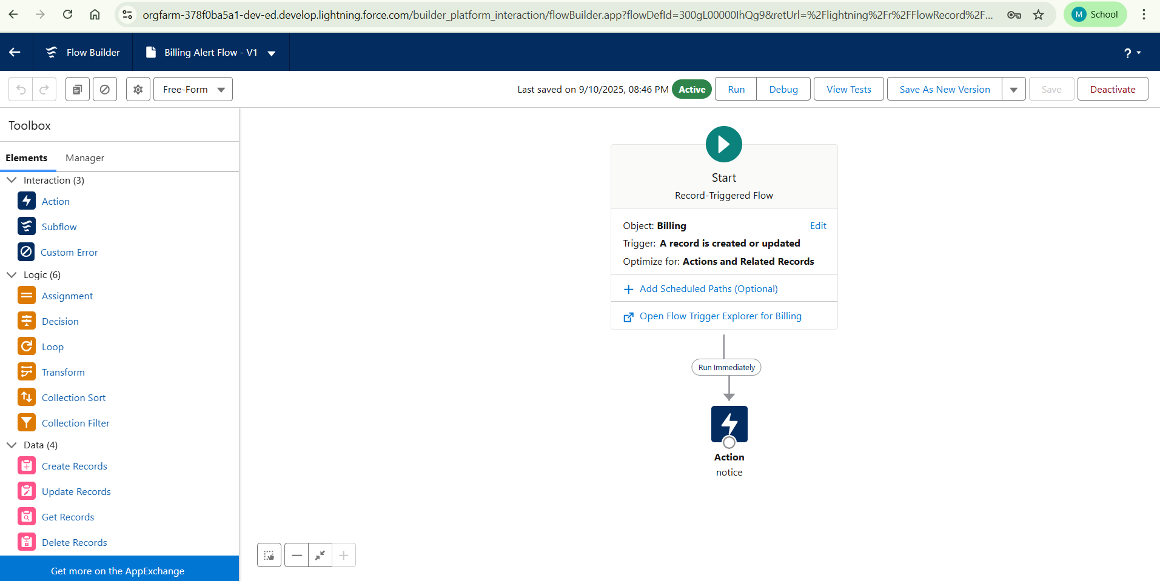

**CONCLUSION**

The CRM application for Jewel Management provides a comprehensive and efficient platform to manage customer relationships, streamline sales operations, and enhance overall business performance. By integrating features such as customer data management, order tracking, billing, and personalized communication, the system enables jewel businesses to maintain strong customer engagement and loyalty. The automation of routine tasks reduces manual effort and minimizes errors, while real-time insights into customer preferences and purchase history support better decision-making. This application not only improves operational efficiency but also creates opportunities for targeted marketing, improved customer satisfaction, and sustainable business growth. Ultimately, the CRM for Jewel Management serves as a valuable tool that bridges the gap between business processes and customer expectations, helping jewel businesses stay competitive in an increasingly digital marketplace.

**APPENDIX**

**UpdatePaidAmountTriggerHandler.apxc**

public class UpdatePaidAmountTriggerHandler {

public static void handleBeforeInsert(List<Billing__c> newBillings) {

for (Billing__c billing : newBillings) {

billing.Paid_Amount__c = billing.Paying_Amount__c;

}

}

public static void handleBeforeUpdate(Map<Id, Billing__c> oldBillingsMap, List<Billing__c> updatedBillings) {

for (Billing__c billing : updatedBillings) {

Billing__c oldBilling = oldBillingsMap.get(billing.Id);

Decimal oldPaidAmount = oldBilling.Paid_Amount__c;

billing.Paid_Amount__c = oldPaidAmount + billing.Paying_Amount__c;

}

}

**UpdatePaidAmountTrigger.apxt**

trigger UpdatePaidAmountTrigger on Billing__c (before insert, before update) {

if (Trigger.isInsert) {

UpdatePaidAmountTriggerHandler.handleBeforeInsert(Trigger.new);

} else if (Trigger.isUpdate) {

UpdatePaidAmountTriggerHandler.handleBeforeUpdate(Trigger.oldMap, Trigger.new);

}

}